Crouch IPLS problems assigned on homework

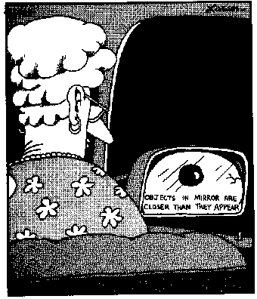
Physics 4L Spring 2010 — Problem set 1

Additional problems:
4. The chambered nautilus considered in class has a region of photosensitive tissue 1 cm in diameter. (a) How close can the nautilus get to the 1-m tall seaweed and still view a complete image of the seaweed if the nautilus’s pinhole is 1 cm in front of the photosensitive tissue? (b) If you assume that the same amount of light still goes through the pinhole, does the image get brighter or dimmer as it gets larger?

Physics 4L, Spring 2010 — Problem set 2

Additional problems:
1. (a) Catherine Crouch’s contact lens prescription is -3.00 diopters. Is she nearsighted or farsighted? As part of your answer, explain the meaning of the negative sign in her prescription.
(b) When she is wearing them, her contact lenses create images of distant objects at the farthest distance where she can see clearly without contact lenses. If she is not wearing her contact lenses, what is the maximum distance at which she can read a computer screen clearly?
(By the way: those of you with the same vision shortcomings can try this – from your prescription you should be able to calculate the maximum distance at which you can read a book or a computer screen pretty accurately. If you’re interested, we can discuss the reasons for small discrepancies ...)

Physics 4L, Spring 2010 — Problem set 3

Additional problems:
1. You are using a microscope that produces an image on the light-sensitive detector of a CCD camera rather than an image viewed with your eye through an eyepiece. The microscope is equipped with a 40x objective lens (i.e. the objective produces an image that is magnified to 40 times the sample’s size) and a second converging lens that produces an additional 2x linear magnification of the real image produced by the objective lens. The arrangement of the sample, the two lenses, and the CCD detector is shown in the figure below; the distances in the figure are not to scale.
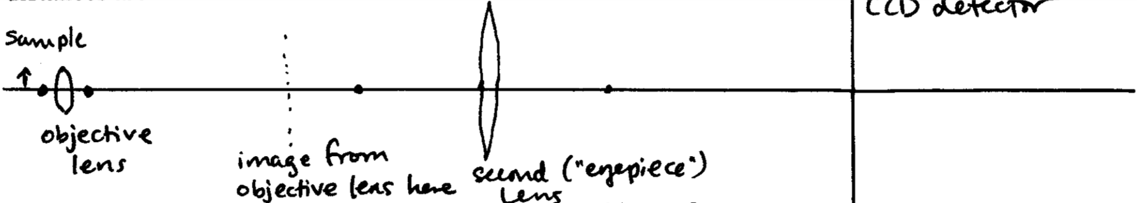

(a) Compared to the image produced by the objective lens, is the image on the CCD camera upright or inverted? Compared to the original sample, is the image on the CCD camera upright or inverted?
(b) The focal length of the eyepiece lens is +10 cm. Find the distance from the eyepiece lens to the CCD detector and the distance from the eyepiece lens to the image formed by the objective lens.
(c) The sample is 2 mm from the objective. How far apart are the objective lens and the eyepiece lens?
Do not try to use the Wolfson formulas about compound microscopes for this problem; they do not apply (this microscope uses lenses differently)! Just consider image formation by the series of two lenses.

Physics 4L Spring 2010 — Problem set 4
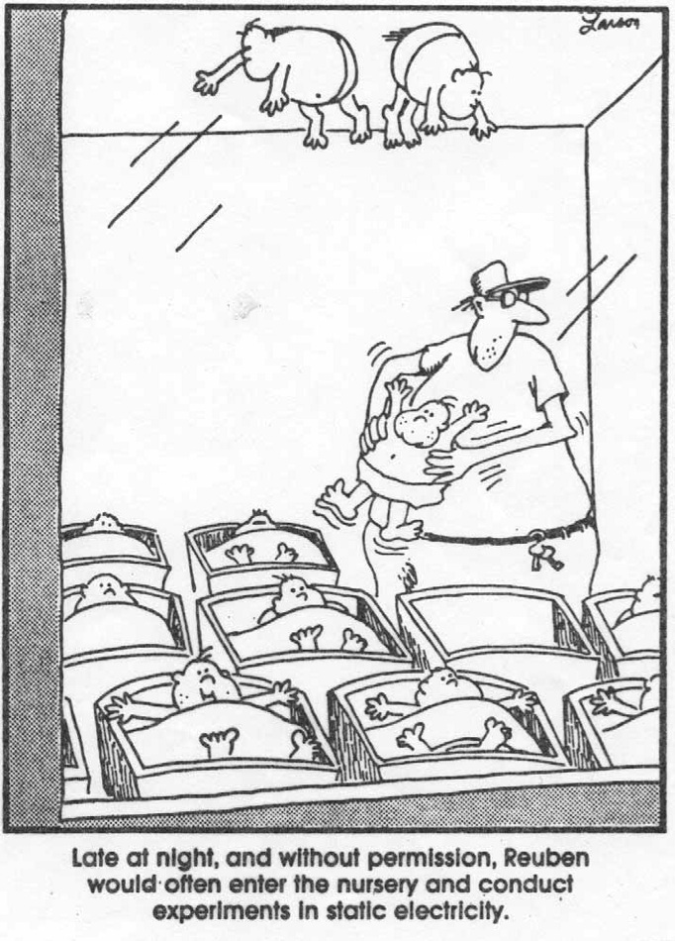
Additional problems:
3. The plasma membrane of a cell has a surface charge density of 2 x 10⁻⁴ C/m² on the outside and an equal magnitude, opposite sign charge density on the inside. The membrane is approximately 5 nm thick. (These numbers are slightly different than the example done in class.)
(a) Is the potential difference from the inside of the cell to the outside positive or negative? Explain briefly.
(b) How much energy is required for a sodium-potassium pump (the enzyme that transfers Na⁺ ions from the inside of the cell to the outside, and K⁺ from the outside to the inside) to transport three Na⁺ ions from the inside to the outside of the cell? (Assume the energy required is just equal to the electric potential energy gained by the Na⁺ ions in moving from the inside to the outside; ignore the energy associated with conformational changes to the enzyme.) The charge of each ion is the elementary charge (1.60 x 10⁻¹⁹ C).

Physics 4L Spring 2010 — Problem set 5

Additional problems:
3. One sodium chloride (NaCl) “molecule” consists of a Na⁺ ion of charge +e and a Cl— ion of charge –e separated by a distance of 0.24 nm. For this problem, assume that the ions are embedded in the same lipid material as a cell membrane (κ = 8).
(a) Find the amount of work by an external force required to remove one ion to infinitely far away from the other) of this molecule. This quantity is sometimes called the binding energy of a molecule. Compare to the binding energy in air (κ = 1) and in water (κ = 80). (If we worked out the values in air and water in class you can just quote those values.)
(b) Suppose the charges of the Na⁺ and Cl were doubled to +2e and -2e respectively. By what factor would the binding energy change? Explain briefly.

Physics 4L, Spring 2010— Problem set 6

Additional problem:
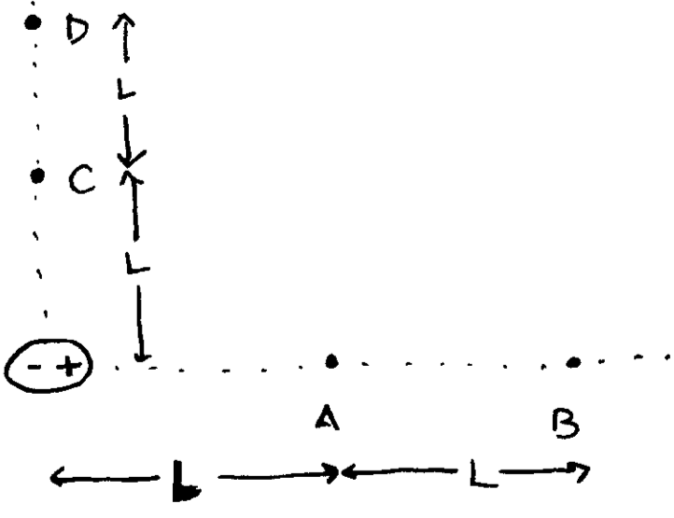
1. The following problem makes use of the same ideas as the analysis in the electrocardiography lab (potential differences in the field of a dipole), except that the points are not located equidistant on either side of the dipole as they were for the electrocardiogram. Also assume that the dipole and all lettered points are surrounded by a medium with κ = 3.
(a) Find the potential difference ΔV_{AB} between points A and B near a dipole shown to the right, in terms of the dipole moment p of the dipole and the distance L from the center of the dipole. The dipole is much smaller than L.
(b) Find ΔV_{CD} in the same situation as part (a).
(c) Find numerical values for ΔV_{AB} and ΔV_{CD} if the dipole has dipole moment p = 6.2 x 10⁻³⁰ C m and the distance L is 1 nm.
(d) Find the change in electric potential energy of a Ca²⁺ ion moving from A to B using the parameters of part (c).



Physics 4L, Spring 2010 — Problem set 9

3. Consider the magnetotactic bacteria we discussed in class. Suppose each magnetic particle in a bacterium is a sphere 50 nm in diameter made of material that has a magnetic moment per volume of M = 5 x 10⁵ A/m. What is the energy required to rotate one such particle 180° so that it goes from having its dipole moment parallel to the Earth’s magnetic field to antiparallel to the Earth’s magnetic field? (Assume the strength of the Earth’s magnetic field is 60 µT.) How does this compare to the thermal energy k_{B}T at room temperature, which is 4.1x10⁻²¹ J? Why do you suppose bacteria typically have 10 to 20 of these particles?

Physics 4L, Spring 2010 — Problem set 10

Chapter 26 problem 69, and comment on how your answer illustrates why superconducting solenoids, which have zero resistance, are usually used to produce very strong magnetic fields, such as those needed for NMR measurements and MRI imaging.

Physics 4L, Spring 2010 — Problem set 11

2. The figure to the right is taken from Organic Chemistry, Maitland Jones, Jr. and shows why the net magnetic field experienced by a proton in a molecule is not exactly the same as the applied magnetic field B₀. Imagine looking at this system from above, so that the applied field appears to be coming directly toward you (“out of the page” if drawn on a sheet of paper). Sketch the proton, the applied magnetic field, and the electron cloud as seen from above, and show the direction of the induced current (i.e. the direction in which the electrons circulate in response to the applied magnetic field.)

Physics 4L, Spring 2010 — Problem set 12

3. In fluorescence microscopy, one color of light is used to illuminate (“excite”) the sample; a dye that is attached to molecules or structures of interest within the sample absorbs a photon of the exciting light, changing its energy, and then emits a photon of a different color of light. Colored filters are used between the sample and the eyepiece or camera so that only the emitted color of light is observed. The specific combination of excitation and emission colors is specific to the particular dye. One such combination is for a dye called Texas Red, which is excited by light with wavelength 596 nm (an orange color) and emits light with wavelength 615 nm (a red color).
(a) Is the energy of a single exciting photon higher or lower than the energy of a single emitted photon?
(b) Do you think there exist dyes for which the energy of an exciting photon is lower than the energy of an emitted photon? Explain why or why not.
(c) In a special type of laser-based fluorescence microscopy called two-photon microscopy, two photons of the exciting light are absorbed by the sample for every single photon emitted. How does the energy of two exciting photons compare to that of one emitted photon? How does the energy of one exciting photon compare to that of one emitted photon?

Physics 4L, Spring 2010 — Problem set 13

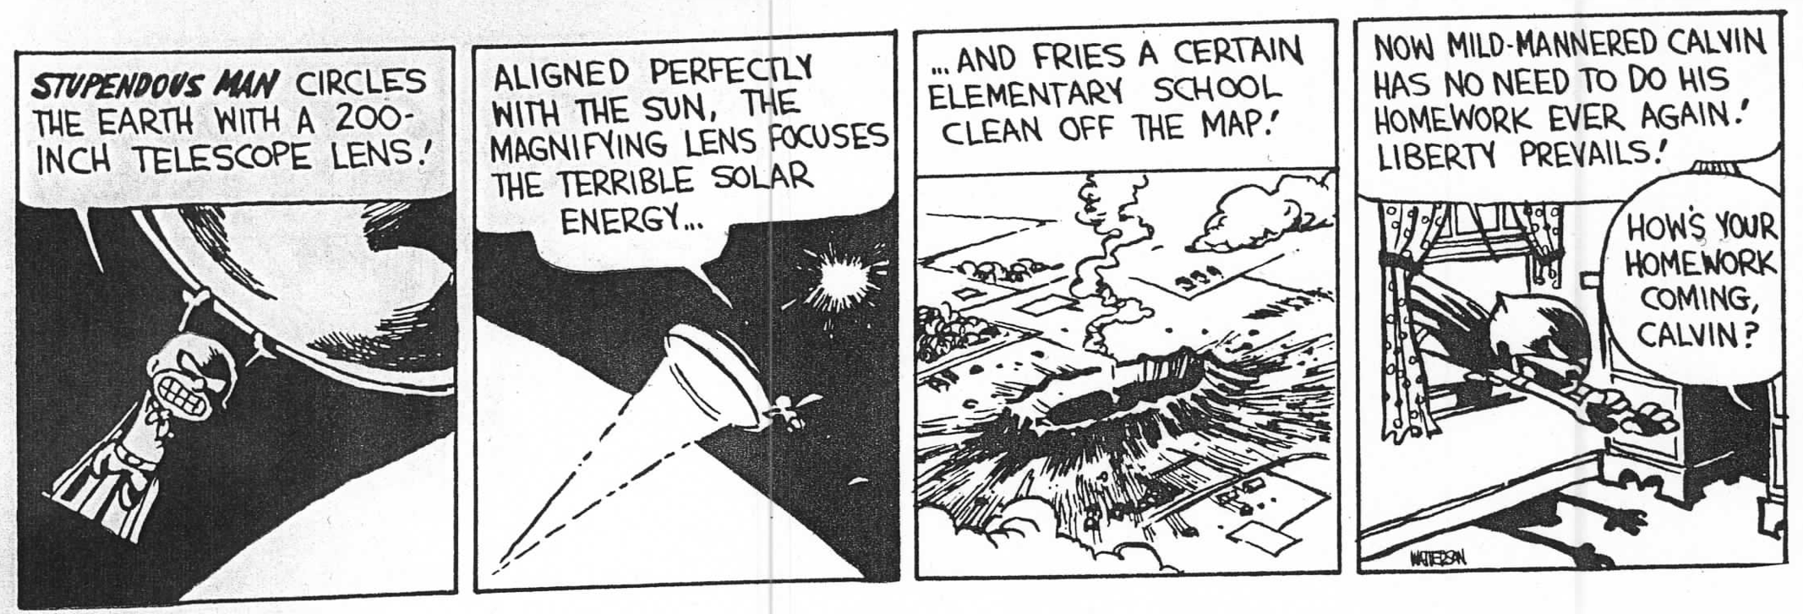

1. You are ordering lenses for a microscope and you want the lenses coated with a thin anti-reflective coating to minimize reflection of 500 nm light. The coating has index of refraction 1.38 and the glass used for the lenses has an index of refraction of 1.52. How thick should you tell the factory to make the coating? Would you need a different coating thickness if the glass used for the lenses had an index of refraction of 1.60? Explain your answers briefly. (Note: to solve this problem, just consider reflections from the air-coating interface and the coating-glass interface, as discussed in class; do not worry about the Maxwell’s equation treatment mentioned by Wolfson.)

2. You are using a microscope equipped with a 60x objective lens with NA (numerical aperture) = 1.4 to examine a specimen using fluorescence from blue fluorescent protein, which emits 445 nm light.
(a) What is the smallest resolvable distance between features in your sample?
(b) If your microscope is connected to a CCD camera and the 60x magnified image is detected by the CCD sensor, how large is the image of the smallest resolvable distance?
(c) If you were examining a specimen in which the structures of interest were marked with yellow fluorescent protein (emits 527 nm light) instead of blue fluorescent protein, would the smallest resolvable distance in your sample increase or decrease? Explain briefly.
(d) The 60x, 1.4 NA objective is extremely common in biological microscopy. Typical research-grade CCD cameras for use in microscopy have square pixels that are 6.25 µm on each side. Explain why this is a wisely chosen size.
Self-test problem, week 1 Name: ______________________________________

You may spend up to 25 minutes on this problem. Do your work on this sheet in the space provided and turn it in separately. Do not work with others or refer to the textbook, though you may consult the equation sheet posted online. Your score on this problem will not be included in your homework grade; it is solely for feedback to you. (However, you will receive credit for one homework problem for completing it.)

A cylindrical optical fiber made of glass with refractive index 1.50 is used to guide the light collected by a medical endoscope. It is inserted into the artery of a patient (with the endoscope on the end). The index of refraction of the surrounding blood is essentially the same as that of water, 1.33. Assume for the purpose of this problem that the fiber axis is perfectly straight.

Light is incident on the flat end of the endoscope from the blood at an angle to the axis of the fiber as shown in the figure. It travels into the glass, and then reflects from the glass-fluid interface to continue traveling along the fiber.
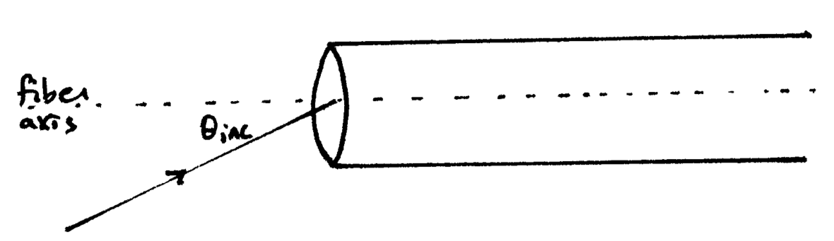
(a) What is the maximum angle θ_{axis} that a light ray going into the fiber can make with the fiber’s axis and undergo total internal reflection along the fiber?

(b) To make the angle larger, so that the fiber can collect light from a larger area, would you want to surround the fiber with cladding material with index of refraction larger than 1.33, or smaller than 1.33? Explain the logic of your answer briefly. Your explanation can be purely qualitative or can involve calculations, either is fine as long as it is rigorous!

(If you need more space, continue on the back)

Self-test problem, PS 2 Name: ______________________________________

You may spend up to 25 minutes on this problem. Do your work on this sheet in the space provided and turn it in separately. Do not work with others or refer to the textbook, though you may consult the equation sheet posted online. Your score on this problem will not be included in your homework grade; it is solely for feedback to you. (However, you will receive credit for one homework problem for completing it.)

(a) If Amy Bug (former Physics 3 professor) holds a physics textbook 30 cm in front of her glasses (prescription +2.25 diopters), where is the image of the page created by her glasses? Is the image virtual or real? Upright or inverted?

(b) Is Amy Bug nearsighted or farsighted? Explain briefly why.

(c) The distance from Amy Bug’s retina to the lens of her eye is 23 mm, and the distance from the lens of her eye to her glasses is 2.0 cm. What is the focal length of her eye’s lens, if the image is in focus? (You may calculate either the focal length in air or the focal length in the eye, as long as you clearly specify which you calculated. Be sure to account for the effect of the index of refraction of the contents of the eye (n_{eye} = 1.34).)
Note: You do not need to include a ray diagram in your solution, but do provide a diagram showing the locations of the glasses, the image formed by the glasses, the eye lens, and the retina, and label the diagram with the distances you used in solving this problem.

Self-test problem, PS 5 Name ___________________________
You may spend up to 30 minutes on this problem. Do your work on this sheet and turn it in separately. Do not work with others or refer to the textbook, though you may consult the equation sheet posted online. Your score on this problem will not be included in your homework grade; it is solely for feedback to you. (However, you will receive credit for one homework problem for completing it.)

Consider the electrical properties of the charge layers on either side of the cell membrane, taking into account the polarization of the lipid material of the membrane. The potential difference between the inside and outside of a cell is 110 mV (outside is positive relative to inside). The membrane is approximately 5 nm thick and the dielectric constant of the membrane is 8.
(a) Find the magnitude of the charge density σ_{ions} of the ions on either side of the membrane.

(b) If the cell membrane dielectric constant was 3 (as in Wolfson problem 60) instead of 8, would your answer to (a) change, and if so, by what factor would it change? (What number would you multiply your answer to (a) by to get the correct charge density?) Explain briefly.

(c) Consider moving three Na⁺ ions from the inside to the outside of the cell. Find the change in electric potential energy associated with this process, and give a qualitative explanation for the sign of your answer (i.e. why electric potential energy is lost or gained, or remains the same).

(Problem continued on the back)
(d) Would the change in electric potential energy you found in (c) change if the membrane dielectric constant was 3 instead of 8? If so, by what factor would it change? Explain briefly.

