**Electrocardiography Homework Problem**

**Swarthmore College Introductory Physics for the Life Sciences**

*Note: in this problem, students do the calculation that is presented in the Electrocardiography Laboratory Appendix. It is provided here for use if the instructor should choose not to go through the calculation in class/lab and doesn’t distribute the Appendix, or wants students to work through the calculation on their own anyway. Appropriate instructions need to be provided and the lab manual edited according to the instructor’s goals! The Appendix could be used as a solution to this problem.*

Consider an electric dipole consisting of charged particles ±*q* at *x* = *a* and *x* = -*a*.

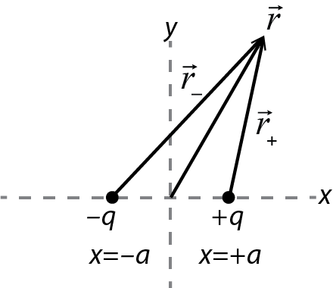

The potential of the dipole at any location  is found by adding the potentials of the individual charges:



Consequently the potential *difference* between any two locations  and  is just found by subtracting the potentials at those locations: 

1. Consider two points on the y-axis given by (0, *y*1, 0) and (0, *y*2, 0). (These two points can be anywhere on the y-axis; when you make a sketch of the problem you can pick any two places to draw those points.)   
   Show by calculating  that the potential difference between these two points is zero, regardless of where *y*1 and *y*2 are chosen.
2. Now consider two points on the *x*-axis given by (*r*, 0, 0) and (-*r*, 0, 0). (This makes the math somewhat simpler.) Derive the result you used to analyze your data, namely, 