**Electrocardiography Laboratory Appendix:**

**Calculating Potential Differences in a Dipole Field**

**Swarthmore College Introductory Physics for the Life Sciences**

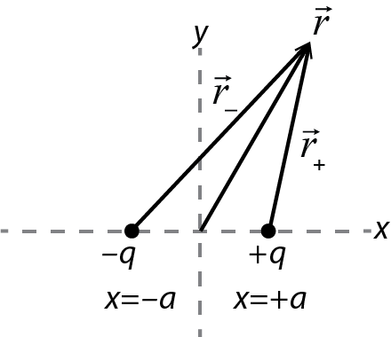The goal of this analysis is to relate measured potential differences on the surface of the body to the components of the heart’s electric dipole moment.

Consider an electric dipole consisting of charges ±*q* at *x* = *a* and *x* = -*a*. The potential of the dipole at any location  can be found by adding the potentials of the individual charges:

 (A.1)

If we embed this dipole in a dielectric with dielectric constant , the potential, like the electric field, is reduced by a factor of :

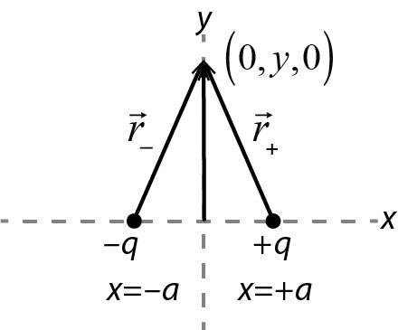  (A.2)

In the dipole investigation at the beginning of lab, you found from an electric field diagram that for a horizontal dipole, is constant along the *y*-axis. You can now confirm this mathematically. Apply (A.2) to any location  on the *y*-axis; , as shown in the figure, and consequently  at any *y*. As a result, produced by this dipole between any locations *y*1 and *y*2 on the *y*-axis is zero:[1]

 (A.3)

Now consider finding the potential difference between two points on the *x*-axis that are equal distances *r* from the origin (at *x* = *r* and *x* = -*r*). The potential at *x* = *r* is given by

 (A.4)

Using the definition of the magnitude of the dipole moment , in the case *r* >>*a*, the denominator of the fraction can be approximated as *r*2 and this can be written as



 (A.5)

The same procedure gives the potential at *x* = -*r* as

 (A.6)

The potential difference between *x* = +*r* and *x* = -*r* is therefore

 (A.7)

The dipole moment of a dipole constructed this way points in the positive *x*-direction. The heart’s dipole moment changes direction during the cardiac cycle, so this is not a complete model of the heart’s dipole moment. However, the heart’s dipole moment  can always be written as the sum of *x*- and *y*-components  and. For a dipole with its dipole moment in the *y*-direction, everything we worked out above applies with *x* and *y* switched, so now the *x*-axis is an equipotential and (A.7) gives the potential difference between locations *y* = ±*r* on the *y*-axis.



Here is the really useful (and cool) point: For any electric dipole, because the axis perpendicular to the dipole is an equipotential, the potential difference between two points on the *x*-axis depends only on the *x*-component of the dipole , and the potential difference between two points on the *y*-axis depends only on . So, in an electrocardiogram, we can measure V between two points on a horizontal line (Lead I) to determine , and we can measure V between two points on a vertical line to determine . In other words, if is measured between ±*x* and if is measured between ±*y*:



and (A.8)



which can be solved to give

and . (A.9)



It turns out that the complexities of human physiology make it difficult to directly measure a potential difference along a vertical line. Due to the way the electric field spreads through the body, it turns out that effectively Lead II is located at 60° to Lead I. Consequently, we use trigonometry to calculate  from the Lead I and Lead II measurements as follows.



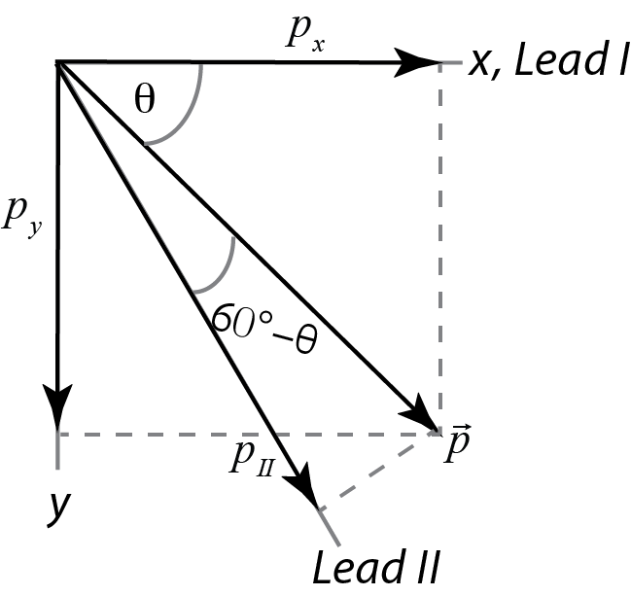

Consider a dipole oriented at an arbitrary angle  as shown. The horizontal and vertical components  and are given by



and . (A.10)



The component of the dipole along Lead II, which we can notate , is given by



(A.11)



which can be simplified using an angle difference formula to

(A.12)



We can then solve for in terms of and:



(A.13)



Finally, we note that the relationship we found above between and and the voltages measured along the corresponding axes is true for any combination of a dipole component and the voltage measured along the corresponding axis. So, it is also true that the component of the heart’s dipole along Lead II is related to the Lead II voltage by



 (A.14)

If the distances at which the leads are all measured are roughly equal, , we can approximate the components of the dipole moment from:

Horizontal:



Vertical:



This pair of equations is true at every instant in time. Within the limits of the approximation that the distances are all the same, the proportion between any component of the dipole moment and the corresponding voltage is the same. Therefore, to plot the time-dependent dipole moment, you can do the calculations and plotting just using the voltages.

To find the maximum dipole moment, find the peak signal in whichever lead shows the strongest signal, and then find the value of the other lead at that same instant of time. Then, use the correspondingand to find the maximum dipole moment.



There are a lot of approximations involved here! Probably the most significant is that the effective angle between Leads I and II will vary somewhat patient by patient due to the patient’s anatomy; the clinical electrocardiogram uses twelve leads to obtain a more comprehensive picture of the three-dimensional behavior. We are doing this simplified analysis so that you understand the basic physics and get a feel for the complex fields generated by the beating heart. If you go on to become a cardiologist, you’ll find that there are more sophisticated and hence more accurate ways to analyze the data.

1. Clarification of a possibly confusing point: Not only is  *constant*, its *value* happens to be zero; what matters is that has the same value for any *y*, so that the potential *difference* between any two points on the *y*-axis is zero.