Instructor solutions for Understanding Microscopes: Ray Diagrams

Planning question 1

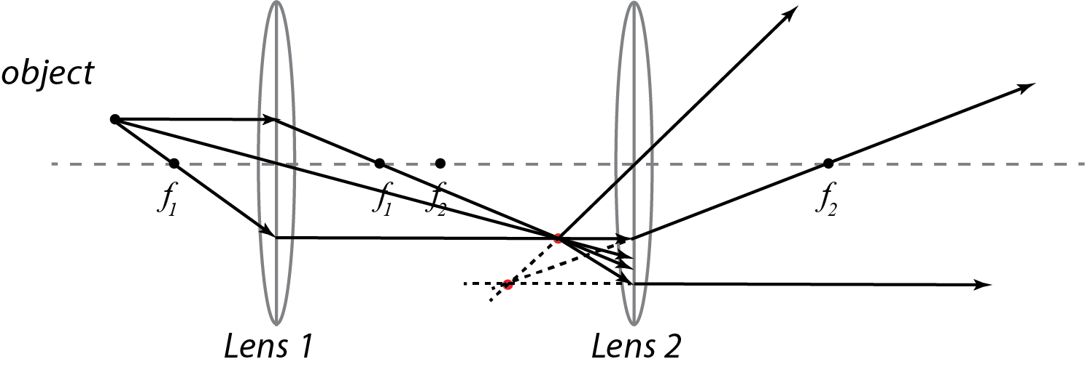

Planning question 2

