Planning Diagrams

Planning question 1

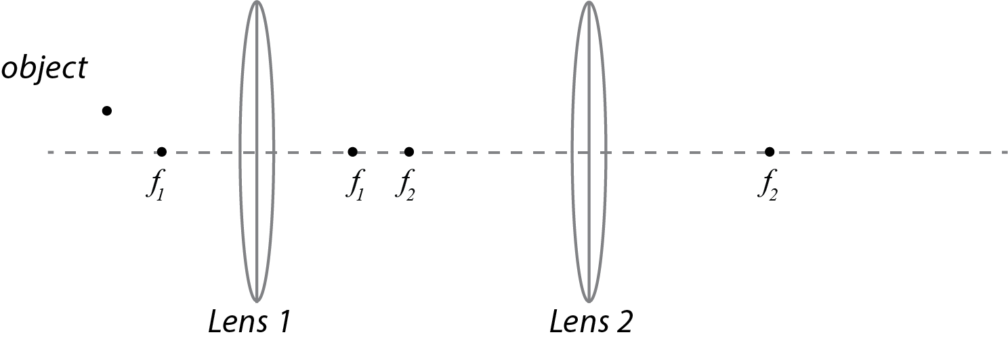

Planning question 2

