Understanding How Microscopes Work: Equipment List
Swarthmore College Introductory Physics for the Life Sciences
PASCO Basic Optics kit, or equivalent:
- Converging lenses with +10 cm and +20 cm focal lengths in holders that mount on track (OS-8456)
- Optics track (OS-8508) with extension (OS-8538) to 2 m length
- Screen (OS-8460)
- Light source (OS-8470)

Lenses of at least this quality are needed for this experiment to succeed. These lenses have substantial spherical aberration. so the “microscope” image will be moderately to significantly distorted. Also, the lenses have a long depth of focus and so identifying the exact placement of the lenses to obtain the best magnified image is difficult. Higher quality lenses can be purchased from other vendors, such as Thorlabs or Edmund Optics, but may be more expensive (as are the corresponding holders and optical rail), may require work from the instructor to mount in holders, and may be more difficult for the students to use.

Other equipment
- Digital calipers or ruler marked in millimeters
- Tape, paper, and pencils (for students to tape paper onto the screen and if necessary, make marks on the paper to measure; otherwise they may mark or scratch the screen accidentally)
- Basic compound microscope with at least two different objectives mounted on a rotating turret (we routinely borrowed these from the biology department for just this lab)
- Stage micrometer (a glass microscope slide with a tiny set of ruler markings, used to calibrate the image scale obtained with the microscope) or other sample to view under the compound microscope
Part 1: Microscope Design

Suppose you have been hired to run the optical microscopy lab at the local hospital. On your first day at work, you discover that the microscopes in the lab, although of very high quality, are quite old and are not equipped to digitally capture the image on a CCD camera. You therefore go to the director of your division with a proposal to purchase new, suitably equipped microscopes. Your director frowns on seeing budget and says, “Just attach CCD cameras to an eyepiece in place of your eye.” Will this do the job, assuming you could find a way to attach the CCD cameras to the eyepieces? To figure this out, in this lab you will construct a simple model of a microscope.

Goals
- To design and construct two different designs of microscope, one that produces a real image on a screen and one that produces a virtual image that must be viewed through the eyepiece lens.
- To answer the question above based on what you learn from doing this lab.
Important: the CCD “camera” commonly used with a microscope has no lens; it is simply an electronic sensor that records the light that lands on it (so records an image that is cast on it).

Planning:
Work through the following exercises with your lab partner or table. Each of you should record your answers and tape your diagrams into your lab notebook.
- The diagram provided below shows an arrangement of a small object and two thin convex lenses analogous to that used in a typical compound microscope. A copy of this diagram is on a separate page for your use. On it, construct rays showing the image formed by lens 1, then use that image as the object for lens 2 and construct rays showing the image formed by lens 2.

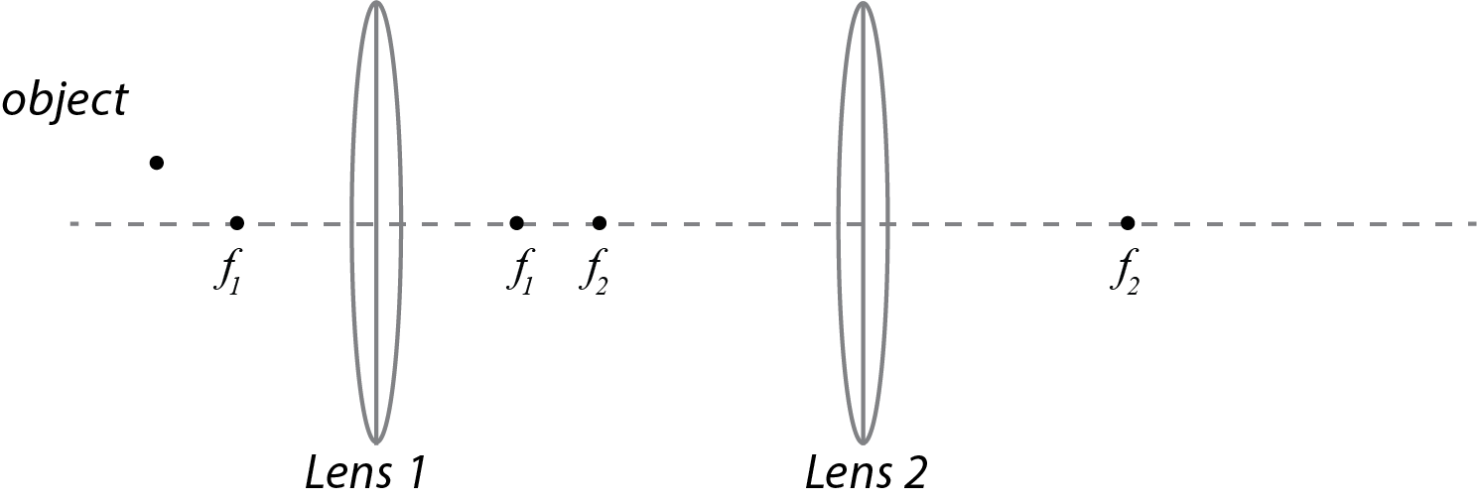
- Think of lens 1 as the objective lens and lens 2 as the eyepiece lens of a microscope. Does the eyepiece lens form an image that could be detected by a CCD camera or cast on a screen? If so, where should the camera’s sensor be placed? If not, is it possible to adjust lens 2 so that its image could be cast on a screen?

- The diagram below shows another arrangement of a small object and two thin convex lenses. On your printed copy of the diagram, construct rays showing the image formed by lens 1, then use that image as the object for lens 2 and construct rays showing the image formed by lens 2.

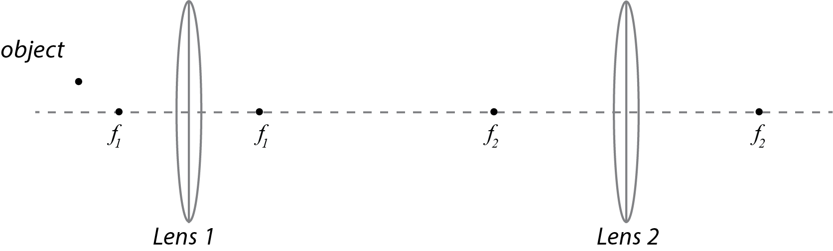

- Think of lens 1 as the objective lens and lens 2 as the eyepiece lens of a microscope. Does the eyepiece lens form an image that could be viewed on a screen? If so, where should the screen be placed? If not, is it possible to adjust lens 2 so that its image could be viewed on a screen?

Measuring f for the “objective lens”
You will use the lens marked “+10 cm” as the objective lens in your “microscope”. To accurately construct the microscope, you need an accurate value for its focal length. (It is not as critical to have an accurate value for the focal length of the second lens, although you can also measure that if you want!)
Determine its focal length from three measurements, recording your measurement method, data, and analysis in your lab notebook as well as your measured value with uncertainty.

Microscope 1: Real image on a CCD camera (electronic sensor)
Design and build an arrangement of two lenses which produces a highly magnified real image on a screen, with most of the magnification coming from the first (“objective”) lens.

Begin by working out a design with your lab group, based on the planning exercises. Then assemble it, and if you need to, adjust the positions of the lenses to improve the image quality. Finally, record your arrangement with a careful diagram in your lab book as described next.

In your lab book, draw a neat diagram showing:
- the arrangement of the source, the lenses (labeled with focal lengths), and your eye
- all the measured distances between the parts
- the focal points of both lenses
- the images formed by each lens
- the distances from each lens to the image it forms
(You do not need to include rays unless you wish to.)

Also in your notebook:
- Record whether the final image is upright or inverted
- Calculate the expected magnification (with uncertainty).
- Measure and record the actual magnification; compare to the expected value. (The image may be distorted, making this difficult; do your best without undue effort.)
Tips for measuring magnification: The crosshair pattern on the light source is marked with its actual size (like the measurement scale provided on some microscope objectives). Measure the size of a feature in the image with the calipers, taking care not to scratch the screen (you may want to mark the size on a piece of paper held up to the screen, then measure those markings with the calipers). Select a feature large enough that you can measure it accurately, but not so large that it will be distorted in a highly magnified image.

Microscope 2: Virtual image viewed by observer
Design and build an arrangement of two lenses in which the first (“objective lens”) produces a magnified real image, and the second (“eyepiece lens”) produces a virtual image that can be viewed by a person’s eye. Look through it. Due to the limitations of the types of lenses we have, don’t try for the maximum possible magnification, just significant magnification.

Record the arrangement of parts with a diagram following the list above under Microscope 1.

Also in your notebook:
- Record whether the final image is upright or inverted.
- Record anything else noteworthy about the image.
You do not need to calculate or measure the magnification; this is very difficult to do with an image observed by eye, as it depends on psychological factors as well.

Examine the compound microscope at your lab station, and identify each part that corresponds to the parts of your model microscope. Also answer the following in your lab book:
- Does the microscope produce a real or virtual image?
- What is the role of the lens of your eye in your ability to perceive the image?
- The light path from the objective lens to the eyepieces is enclosed by a solid box. How might this improve the images a user can see through the microscope?
Conclusions
In your lab notebook, address the following two points:
For each of the two microscope designs, explain why the image formed by the second lens is real or virtual, based on the location of the image formed by the objective lens. Also explain why it is upright or inverted.

Which design is required to detect the final image on a CCD camera sensor? For the microscopes at the hypothetical lab described in the introduction, explain what modifications would need to made, and whether buying new microscopes is needed.

For further thought:
You may be wondering why microscopes have two lenses — it may seem like a single lens can work perfectly well as a microscope! In fact, the image produced by the objective can be captured directly on a CCD sensor without a second lens; some high-end research microscopes do this. However, this works because CCD sensors can detect very tiny images with high resolution, and the stored images can then be magnified by computer software to be large enough for the viewer. The image produced by a 60x microscope objective is still too small for the unaided human eye to see all the details.

Prior to digital camera technology, using an eyepiece lens offered two advantages, both to enlarge the image further, and also to make it easy for a scientist to reliably view it when sitting at the microscope. Even with digital cameras, it’s usually convenient to be able to view the image directly, so most research microscopes allow the user to switch between viewing the image through an eyepiece and using a different second lens to relay the image to a camera. This second lens frequently does not provide further magnification, because for reasons of engineering, it’s easier to get the highest quality final image that way.

Follow-Up Notes on Digital Microscopy

The following is optional additional information for those who are interested, but not required!

Modern microscopy is typically done using CCD cameras to record images. Unlike cameras for photography, ordinarily CCD cameras do not have lenses in front of the detector chip— the sensor chip is simply protected with a transparent window. In addition, the size of the sensor and its individual pixels are such that the magnification provided by the microscope objective is the right amount of magnification to reveal the finest details resolvable and to capture the entire image; further magnification by a second lens would make the image too large for the sensor.

For this reason, microscopes are designed with ports to which the CCD camera can attach, so that the image produced by the objective will fall directly on the sensor. (For a high-quality microscope equipped with what is called an “infinity-corrected objective”, the story is a little more complicated and actually does involve a second lens which does not provide any further magnification, but for the purposes of understanding the basics, you can think of this as the image produced by the objective alone.) Then there is a mirror (or a prism operated in total internal reflection mode, as in last week’s lab) that can be positioned to direct the rays coming from the objective either toward the CCD camera or toward the eyepiece.

Before CCD cameras, microscopes were sometimes provided with so-called “photoeyepieces” which could produce a real image on the film plane in a photographic camera with the camera’s lens removed. A microscopist could thus view the sample looking through a normal eyepiece, then remove one eyepiece and replace it with a photoeyepiece with camera attached, and take a picture of the sample. So the lab director’s idea is not so crazy ... but has been rendered obsolete in most modern microscope technology.
Part 2: Magnification and Focal Length

You have learned in this course that the basic characteristic determining how a lens focuses light is its focal length. Any lens can produce a variety of image sizes, depending on where the object is positioned: the image can be highly magnified, the same size as the object, or smaller. However, lenses on a microscope are labeled with a magnification, not a focal length. Why is that?

In this part of the lab, you will make observations designed to help you understand why, when mounted in a microscope, a lens produces an image with a particular magnification. You will also understand why the lenses that produce higher magnification have shorter focal lengths.

Background: More on microscope design
In order to view the sample at different levels of magnification, microscopes are typically equipped with three or more objective lenses. These lenses are mounted on a rotating turret so that they can be switched without moving the sample. It’s easier to focus at low magnification than at high magnification, so the whole microscope is designed so that when the lenses are switched, the image produced by the new objective is very close to in focus. To sharpen the focus, it is sufficient to move the sample very slightly closer to or farther from the objective lens (by turning the “focus” knob).

When changing objectives to change magnification, in order to keep the image in focus, the image formed by the objective lens must remain in the same location. As discussed above, in order to benefit from the ease of focusing he sample location also needs to stay very nearly the same. So what can change? The lens can be mounted at a different distance on the turret, so that the distance from the sample to the lens (called the “working distance”) can change.

The image formed by the objective lens serves as the “object” for the second lens. The second lens doesn’t move when objectives are changed, so in order to produce a properly focused final image, all of the objectives need to produce their images in the same location.

Your instructor will show you how light travels through a compound microscope. If you are not familiar with using a compound microscope, your instructor will show you how to examine an object under low magnification and then change the objective to increase the magnification.

Measurements
Using the optical rail system, set up just the +20 cm lens to produce a magnified focused image of the light source on a screen, and record the positions of all the parts and magnification of the image. This lens is serving as a model of just the objective lens producing an image of the sample.

Then substitute the +10 cm lens into your model in a manner that imitates changing objectives in a microscope, again recording the arrangement of all the parts and the magnification.

With your lab table discuss the following; using the compound microscope provided to check your thinking as needed:
- To be equivalent to changing objective lenses in a microscope, which parts of your model (object, lens, image) must be fixed in place? Which part(s) move(s)?
- When you replace the +20 cm lens with the +10 cm lens in your model, how do you expect the magnification of the image will change? Which corresponds to the “higher magnification” lens?

Conclusions
In your lab book, summarize your findings, including answering these questions
- What do you conclude about the relationship between focal length and magnification? (What other parameters are involved in determining that relationship? Why is it reasonable that microscope lenses are simply marked with magnification?)
- Look at the compound microscope provided. Is the higher magnification objective closer to or farther from the sample? Explain how this is consistent with the observations you made of your model.

Optional Follow-up: Focusing Images
Turn on the illumination for the compound microscope nearest your station, and place one of the samples provided on the microscope stage. Be very cautious in focusing just to be sure to avoid damaging the objectives.

Position the lowest magnification objective above the sample and turn the focusing knob so that you can see a sharp image of the sample. Then turn the focusing knob gently, to gain a sense of how rapidly the image goes in and out of focus. Then switch to the highest magnification. Does the focus disappear more or less rapidly at higher magnification?

How far the objective lens can be moved before the image goes out of focus depends on two properties of imaging systems known as depth of field and depth of focus, which we will not have time to study in great detail (though if you are a photographer you may already know about these). The lenses we used in lab to build the model microscope have long focal lengths, in order to allow us to easily work with this equipment, and consequently have long depths of field and focus. For this reason, in your model, you could move the lens a significant distance while the image grew gradually more blurry, and you may have found it difficult to identify the position giving the most focused image. On a real microscope, all the lenses involved have much shorter focal lengths and so the depth of field and focus are much shorter.
Based on the first part of this lab, you may be wondering why microscopes have two lenses — it may seem like a single lens can work perfectly well as a microscope! In fact, it is possible to capture the image produced by the objective directly to a CCD camera without using any eyepiece lens. However, that is workable because CCD cameras can detect images that are still very tiny with high resolution, and then magnify them electronically. The image produced by a 60x microscope objective is still too small for the unaided human eye to see all the details.

Prior to digital camera technology, using an eyepiece lens offered two advantages, both to enlarge the image further, and also to make it easy for a scientist to reliably view it when sitting at the microscope. Even with digital cameras, it’s usually convenient to be able to view the image directly, so most research microscopes allow the user to switch between viewing the image through an eyepiece and using a different second lens to send the image to a camera.

Planning Diagrams

Planning question 1

Planning question 2

A CCD camera is a very sensitive type of digital camera used on microscopes and telescopes to record images obtained in scientific research. CCD stands for “charge-coupled device,” which describes the sensor technology in the camera. Importantly, typically such a camera does not have its own lens; the lenses of the microscope or telescope form the image, and the camera just provides the sensor to record the image.
Questions 1 and 3 inspired by Tutorials in Introductory Physics, McDermott, Shaffer, and the University of Washington Physics Education Group, “Convex Lenses” homework, p. HW-140 (Prentice Hall, 2003).
If the object is a biological specimen that is mounted on a glass microscope slide and sealed with a cover slip, the working distance is defined as the distance from the objective lens to the surface of the cover slip.

