**Electrocardiography Laboratory**

**Swarthmore College Introductory Physics for the Life Sciences**

**Objectives:**

* To observe the potential differences generated by the human heart on the surface of the body by measuring an electrocardiogram (ECG).
* To gain experience measuring potential difference (“voltage”).
* To determine the time-dependent dipole moment of your heart (or your lab partner’s heart) from measured ECG data.
* To gain a deeper understanding of potential differences produced by an electric dipole, specifically, how perpendicular components of the dipole produce potential differences along perpendicular axes.

**Overview**

In this lab, you will measure your own (or your lab partner’s) **electrocardiogram**: a set of time-dependent potential differences that the heart generates between selected points on the surface of the body. This measurement allows determining the components of the time-dependent electric dipole moment of the heart, which are produced by the discharging (“depolarization”) of the cell membranes of the cardiac muscle cells making up the heart.

Because the electrical activity of the heart governs its mechanical pumping behavior, observing the time-dependent electric dipole moment is a way to observe the functioning of the heart. A leading interventional cardiologist says that the electrocardiogram is the “among the most valuable clinical tests available to medicine because it is quick, completely safe, painless, inexpensive, and rich in information.”

Today you’ll carry out a simplified version of this critically important measurement (and experience that it is safe and painless!), gaining experience with how it works; you will use your data to display the dipole moment vector of your heart (or your lab partner’s) and watch it change with time; and you will investigate how the shape of the electric field of a dipole allows determining the dipole vector’s components by measuring a set of potential differences.

**Preparation**

1. Read the lab overview.
2. Review last week’s reading and class notes on electrocardiography and the electric potential produced by a dipole.
3. In your lab notebook, sketch a set of perpendicular axes and draw an electric dipole with dipole moment **at the origin, pointing along the horizontal axis**. Make your diagram **large** so that you have plenty of room to draw carefully.
   * Sketch the electric field of this dipole.
   * Based on the electric field, construct a set of equipotential contours.
4. Compare your sketch to your measurements from lab last week and to the diagram of the equipotentials of a dipole in the lecture slides from last week. Make corrections to your sketch if needed. You will use this sketch in the starting activity in lab.

**Lab Activities**

**I. Dipole Investigation**

The goal of this investigation is to understand how measuring potential differences along a particular axis allows determining the *component* of the heart’s electric dipole moment along that axis. With your lab partner/table, discuss the series of questions below. Take your time to be sure everyone in your group is comfortable with your answers and explanations. Use the electric field and equipotential diagrams you drew in the prelab preparation to aid your thinking, as well as your measurements from last week.

Consider making measurements of potential difference around a **horizontal** dipole at the origin of your chosen coordinate system.

1. Suppose you measure the potential difference between two points (call them 1 and 2) on the **vertical** axis. (Draw a sketch showing these two locations to aid your visualizing this situation.) We can call this measurement *V*vert. Does the value you obtain for *V*vert depend on what two points you select to measure between? Why or why not?
2. Suppose you measure the potential difference between two points on the **horizontal** axis outside the dipole. Just to keep things simple, let’s assume you choose the points to be at equal distance from the origin (i.e., if the horizontal axis is the *x*-axis, *x* = *d* and *x* = -*d*), so that we can call this *V*horiz(*d*). (The basic idea doesn’t depend on this assumption but it makes it simpler to think about. Again, draw a sketch.)
   1. Does the value you obtain depend on the value of *d*? Why or why not?
   2. 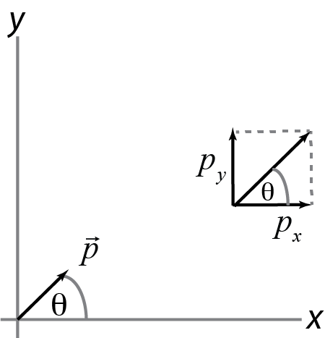What else does the value of *V*horiz(*d*) depend on besides the distance *d*? You don’t need to give a formula here but you should identify which physical quantities in the situation determine the value. Explain briefly how you identified these.
3. Now consider what would happen if the dipole is an angle  to the horizontal, as shown in the figure. The components of the dipole moment are *p*x and *p*y.
   1. Does *V*horiz(*d*) depend on *p*x, *p*y, or both? Explain why.
   2. Does *V*vert(*d*) depend on *p*x, *p*y, or both? Explain why.

*After discussing, check your answers and explanations with your lab instructor and write a brief explanation for your answers in your lab notebook.*

The preceding investigation was designed to help you find that even though potential difference is **not** a vector, **the potential difference produced by a dipole between any two points along an axis passing through the dipole is proportional to the component of the dipole moment along that axis**.

This result tells us how measuring electric potential differences on the surface of the body — electrocardiography — reveals the heart’s electric dipole moment. To measure the horizontal component of the heart’s dipole moment, *px*, we measure a potential difference between two points on the horizontal axis passing through the heart. To measure *py*, we can (in principle[1]) measure a potential difference between two points on the vertical axis. On the follow-up homework problem, you’ll do the calculation to derive the mathematical formulas that are used to determine *p*x and *p*y from measured potential differences. [2]

**II. Apparatus**

Your lab station is equipped with two ECG sensors connected to the data acquisition computer. Each sensor is used to measure a single potential difference as a function of time. Each sensor has three wires with clips on the end: red, black, and green. The sensor measures the potential difference between the green and the red wires, with the red lead positive. In other words, . The black lead is used to set the reference point of potential, which in this lab you will place on the “patient’s” right ankle. (This is equivalent to the black, or “ground,” terminal on power supplies.) The black wire is used so that multiple sensors can be used simultaneously, all with the same zero.



A clinical electrocardiogram measures twelve potential differences. In this lab we measure just two, which allow you to determine the approximate dipole moment of the heart in the plane of Figure 1, known as the “frontal plane”. The twelve-lead ECG allows determining the three-dimensional vector dipole moment, including the component perpendicular to the frontal plane. However, due to the positioning of the heart in the body, a lot of the information in the ECG is still visible with our simplified measurement; the original electrocardiogram only measured the heart’s dipole moment in the frontal plane.

Clinically, each potential difference is referred to as a “lead” (short for “electrical lead,” even though measuring a potential difference actually requires two leads). We will measure two potential differences called “Lead I” and “Lead II,” shown in Figure 1 (drawn as if you are the doctor looking at the patient). The boxes represent the sensors; + and – mark the positive and negative sensor leads. The heavy arrow represents the direction of the dipole moment measured by that sensor.

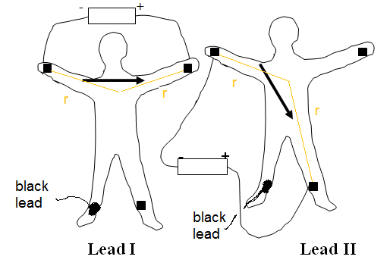

Figure 1: Electrocardiography “Lead I” and “Lead II” measurement configurations.

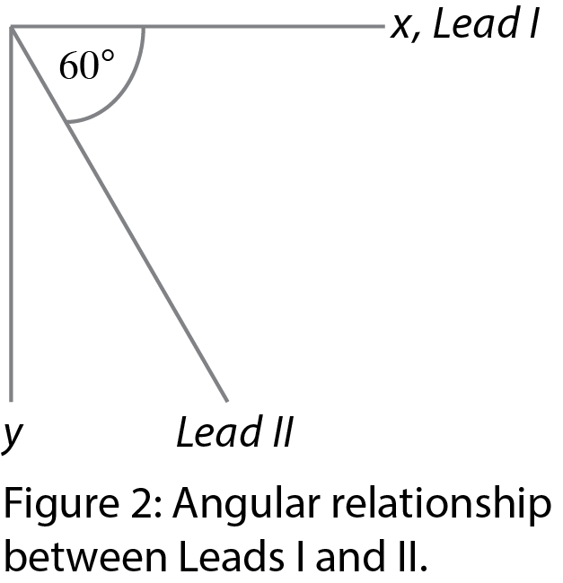Lead I measures the potential difference between two points on an approximately horizontal line. Consequently, the Lead I signal measures the horizontal (*x*) component of the heart’s dipole moment.

Because of how the heart’s electric field spreads through the body, Lead II measures along a line that is equivalent to roughly 60° below horizontal (Figure 2). As described in the Analysis appendix, Lead I and Lead II can be combined to determine the potential difference along a vertical line, and hence the vertical (*y*) component of the heart’s dipole moment.

You will measure Lead I and Lead II potential differences vs. time simultaneously, and from these data determine the trajectory of the dipole moment of the heart. An example of clinical Lead II data are shown in Figure 3: this is a graph of potential difference vs time.

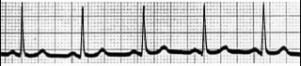

Figure 3: Clinical Lead II ECG data

**III. Relating key features of ECG data to the heart’s activity**

Figure 4 shows a schematic of a single cycle with the different features labeled with electrocardiography nomenclature. As discussed in detail in the reading, each cycle comes from a single contraction of the heart. The peak labeled P shows the depolarization spreading across the smaller chambers of the heart (the atria); it is small because the atria contain only a small fraction of the muscle mass of the heart (see image at the end of the lab manual).

The interval from Q to S, called the “QRS complex,” comes from contraction of the large chambers (ventricles) of the heart; these chambers accomplish most of the pumping. On at least one of the leads, the QRS complex is almost always the largest feature in the ECG.

Finally, the T peak is associated with the repolarization, or recharging, of the ventricles in preparation for the next cycle. (Repolarization of the atria occurs during the contraction of the ventricles and is hidden in the QRS complex.) During repolarization, the membrane charge state goes back to the resting state (negative on the inside, positive on the outside) by means of a moving wave of repolarization. As repolarization involves positive charge moving out rather than in, the moving dipole moment of a repolarizing fiber is opposite to that of a depolarizing fiber.

**P QRS T**

Figure 4. Schematic of a single cycle in an electrocardiogram.

The essentially flat voltage level between the P, QRS, and T features is called the **baseline**. These periods correspond to when the heart muscle is not electrically active, and hence its state of contraction or relaxation is not changing.

*Discussion question 1:*

Based on what you have learned about electrocardiography from the reading and this lab so far, what is surprising about the T wave portion of the schematic shown in Figure 4? Do you have any ideas for how to explain this surprising aspect? (Don’t worry if you don’t have such ideas but see what you can come up with!)

*After discussing this with your lab table, check with your instructor and record a summary of your discussion in your notebook.*

**IV. Experiment: ECG measurement**

* Check that the two ECG sensors are connected to the ECG1 and ECG2 inputs on the USB interface box to the computer.
* Decide which member of your lab group will be the “patient.”
* Before attaching the sticky gel electrodes to the “patient,” use alcohol wipes or soap and water to clean the skin at the four electrode positions marked on Figure 1 (right and left ankles and right and left inside of elbows, or wrists if clothing covers elbows). Skin oils will degrade electrical contact.
* Press four electrodes onto the “patient’s” skin, one each of in the four positions.
* Connect the two ECG sensors to the electrodes by attaching the sensor clips to the black tags on the gel electrodes. **To avoid confusion, connect the sensor connected to “ECG 1” on the Vernier interface box in the Lead I configuration and “ECG 2” in the Lead II configuration** (Figure 1)**.** The sensor measures the potential difference between the red and green electrodes, .



* Check your connections against Figure 1 (red is positive, green is negative) Because the black wire is the reference point where potential is zero, **both black wires should be attached to the same electrode on the right ankle.**
* Launch Logger Pro on the data analysis computer. Under Experiment 🡪 Data Collection, set the sampling rate to 200 samples/s and the experiment duration to 5 s.
* **Zero the sensors (**Experiment 🡪 Zero). Zeroing the sensors should bring the baseline close to zero, though it may not be exactly zero.
* **Take data** (press the toolbar “play” button or choose Experiment 🡪 Start Collection).

Your Lead I or Lead II data (or both) should look something like those shown in Fig. 3.

For the quantitative analysis of your ECG data, you will need a good data set. Specifically, make sure your data set has the following properties, and retake the data if not:

* The baseline of both the Lead I and Lead II data (before the start of the P wave) should be zero within the noise level. If either has a nonzero baseline, either rezero the sensors and record new data, or create new columns of data and subtract the baseline value from the data.
* The amplitude of the signal on at least one lead should be a few mV and the duration of the QRS complex should be 60-80 ms; if yours are very different, check with your lab instructor to be sure you have set up the measurement correctly. You can inspect individual data points using a cursor (Analyze🡪 Examine; the data values under the cursor show up in the box at the upper left.)
* The data should not be overly noisy (the P wave should be visible in at least one of the leads; if you’re unsure, check with your instructor).

When you have a good data set, **save your data for analysis later and print the graph**.

**Include a printout of your two-lead ECG data in your lab book. On the printout, label the overall voltage amplitude and time duration of the** **QRS complex on each of the two measurements; use the Logger Pro data tools to measure those values.**

*Discussion question 2:*

Considering how potential differences are measured,what will happen to your ECG if you switch the green and red wires for **both** Leads I and II? (Clinically this is called “lead reversal.”)

After you and your lab partner discuss what you expect, try it — record a new set of data with the wires switched (though you don’t need to print it out). Was your prediction correct?

*Describe in your lab book what you observe when the leads are reversed, and explain your observation in terms of how potential differences are measured.*

#### V. Analysis

1. **Calculating the time-dependent electric dipole moment of the heart**

The equivalent electric dipole moment of the heart, , is a vector. It can be written as the vector sum of components, *p*x, *p*y, and *p*z. In today’s lab, we will determine *p*x and *p*y only, as they can be found from Lead I and Lead II, as shown in the “Analysis” appendix and summarized below. (You can’t easily measure the *z*- component of the dipole today, as you’d have to take off your shirt to measure the voltage from front to back!).

Because Lead I is measured along a horizontal axis, the *x*-component of , *p*x, is proportional to the zeroed Lead I voltage. The *y*-component *p*y is proportional to the potential difference that would be measured along a vertical axis, which can be calculated from Leads I and II:

Horizontal:



Vertical:



and .



Your goal is to visualize your heart’s dipole moment by plotting the time-dependent calculated from your data. Find *V*horiz and *V*vert at every time point of your data as follows:

1. Rename the column with the Lead I data “*∆Vhoriz*” or something similar.
2. Calculate *∆V*vert = 1.15(Lead II – (Lead I)/2) in a new column in Logger Pro (Data -> Calculate Column) and name that column something like “*∆Vvert*”; make a new graph in Logger Pro displaying *∆Vhoriz* and vs. time.
3. **Plotting the time-dependent electric dipole moment of the heart**

Start by sketching plots of a few points manually to get a feel for what is happening in your data. Choose whichever of Leads I and II has the largest features. In Logger Pro, inspect the graph to identify the approximate times at which the peaks of the P, QRS, and T features occur.

**Find the rows for those times in your data. Using the voltage values at those times, sketch the vector at each of those times in your notebook. Label your sketches with the time (including units) and the corresponding feature (peak of P, QRS, or T).**

Now, let’s display how your heart’s dipole moment changes with time using Mathematica!

First, follow these steps to put the data in the format that Mathematica can use:

1. Export your data into CSV format (File🡪 Export All 🡪 CSV), giving it a filename with no spaces, and open the file in Excel. You should have a time column, the *∆Vhoriz* data, the Lead II data, and then the *∆Vvert* data.
2. Delete the Lead II data, leaving only three columns in this order: time, *∆Vhoriz*, and *∆Vvert*.
3. Delete the headers so that your sheet contains only data.
4. Finally, using the cursors in your graph in Logger Pro, identify the single cycle in your data with the largest amplitude, and find the times at which it starts and ends, starting during the resting period before the P wave and ending right after the T wave finishes. By scrolling or searching through the time (leftmost) column of your CSV file, delete all the data in the CSV file that are before and after that cycle, so that your data file contains only a single cycle of data.
5. Save the file, keeping it in .csv format.

When your data file is ready:

* Open the Mathematica notebook provided on the lab computers (called ecg.nb). The first line of the notebook is: data = Import[]
* Import your data file by putting the cursor between the square brackets and then using the Insert -> File Path command to select your data file in the dialog box.
* Then choose Evaluation -> Evaluate Notebook. This may take a little while, but eventually a set of axes with a “play” button should appear.
* Run the animation by pressing the “play” button. The animation shows an arrow representing the dipole moment and also keeps a trace of the position of the peak of the arrow, so that the path followed by the tip of the dipole moment is visible. It should look something like Figure 5!

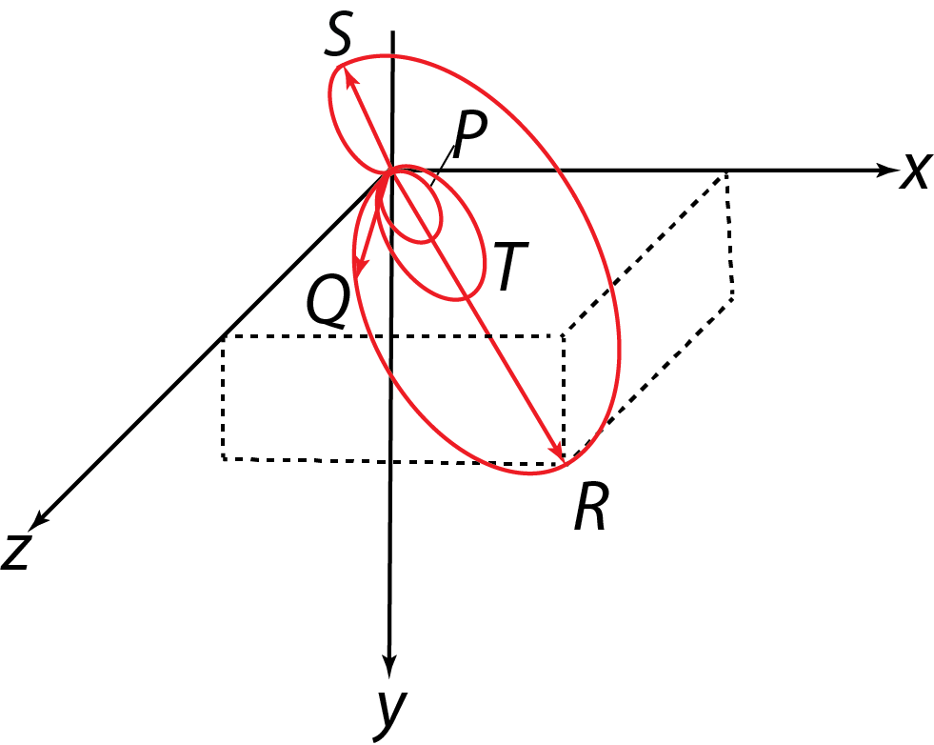

Figure 5: Example of three-dimensional path taken by the tip of the cardiac dipole moment** during a cardiac cycle; the *x*-*y* plane is the frontal plane. Vectors for** are shown at the instants *Q*, *R*, and *S* (as in “QRS complex”). Adapted by CHC from Fig. 6 of R. K. Hobbie, *Am. J. Phys* 41:824-31 (1973).

1. **Calculate your heart’s peak dipole moment (magnitude and direction)**

In Logger Pro, calculate a new column for the magnitude of the total dipole moment: . Graph this column vs time, and find its peak value.



Use the peak value of this column, along with the corresponding *∆Vhoriz* and *∆Vvert*, to estimate the magnitude and direction of the equivalent electric dipole moment of the heart at this peak. Make a reasonable estimate for the distance *r* from the center of the chest cavity to the point where the potential is measured. The dielectric constant of water κwater is about 80 (a unitless number) and ε0 = 8.85 x 10-12 C2/(N•m2).

From your estimates for peak *p*x and *p*y, determine the magnitude and direction of your heart’s peak equivalent electric dipole moment in the frontal (*xy*) plane. You should find a value on the order of 10-13 Cm, but as this is an estimate, yours might be somewhat different.

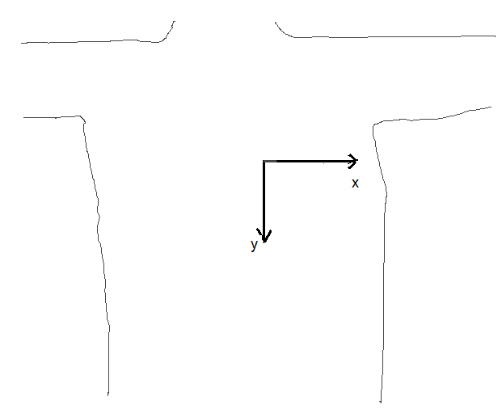

**In your notebook, sketch a vector showing the direction of your peak dipole moment on axes matching those shown in the figure at the right, making sure that direction is consistent with your individual Lead I and Lead II data.** This direction typically varies from 30° above the +x direction to the +y direction as defined here.

*Discussion question 3:*

To get a sense of the significance of this number: **How does the value you found for your peak dipole moment compare to the permanent dipole moment of a water molecule?** Comment on whether this suggests that the dipole moment of the heart is surprisingly large or surprisingly small, or neither, and why.

**To include in your lab notebook:**

* Dipole investigation responses
* Printout of the ECG data from the two simultaneous measurements, labeled with overall voltage amplitude and time duration of the QRS complex on each trace
* Sketches of dipole moment vector from peak times of P, QRS, and T (Analysis part B)
* Printout of finished animation showing path taken by dipole moment (Analysis part B)
* Calculation of the magnitude and direction of heart’s dipole moment at the peak signal, sketch of the direction of the maximum dipole vector (Analysis part C).
* Answers to questions 1-3 interspersed among your data and analysis.

**Appendices**

**1. Schematic of heart chambers and path of depolarization** (from the electrocardiography reading; figures provided here for quick reference).

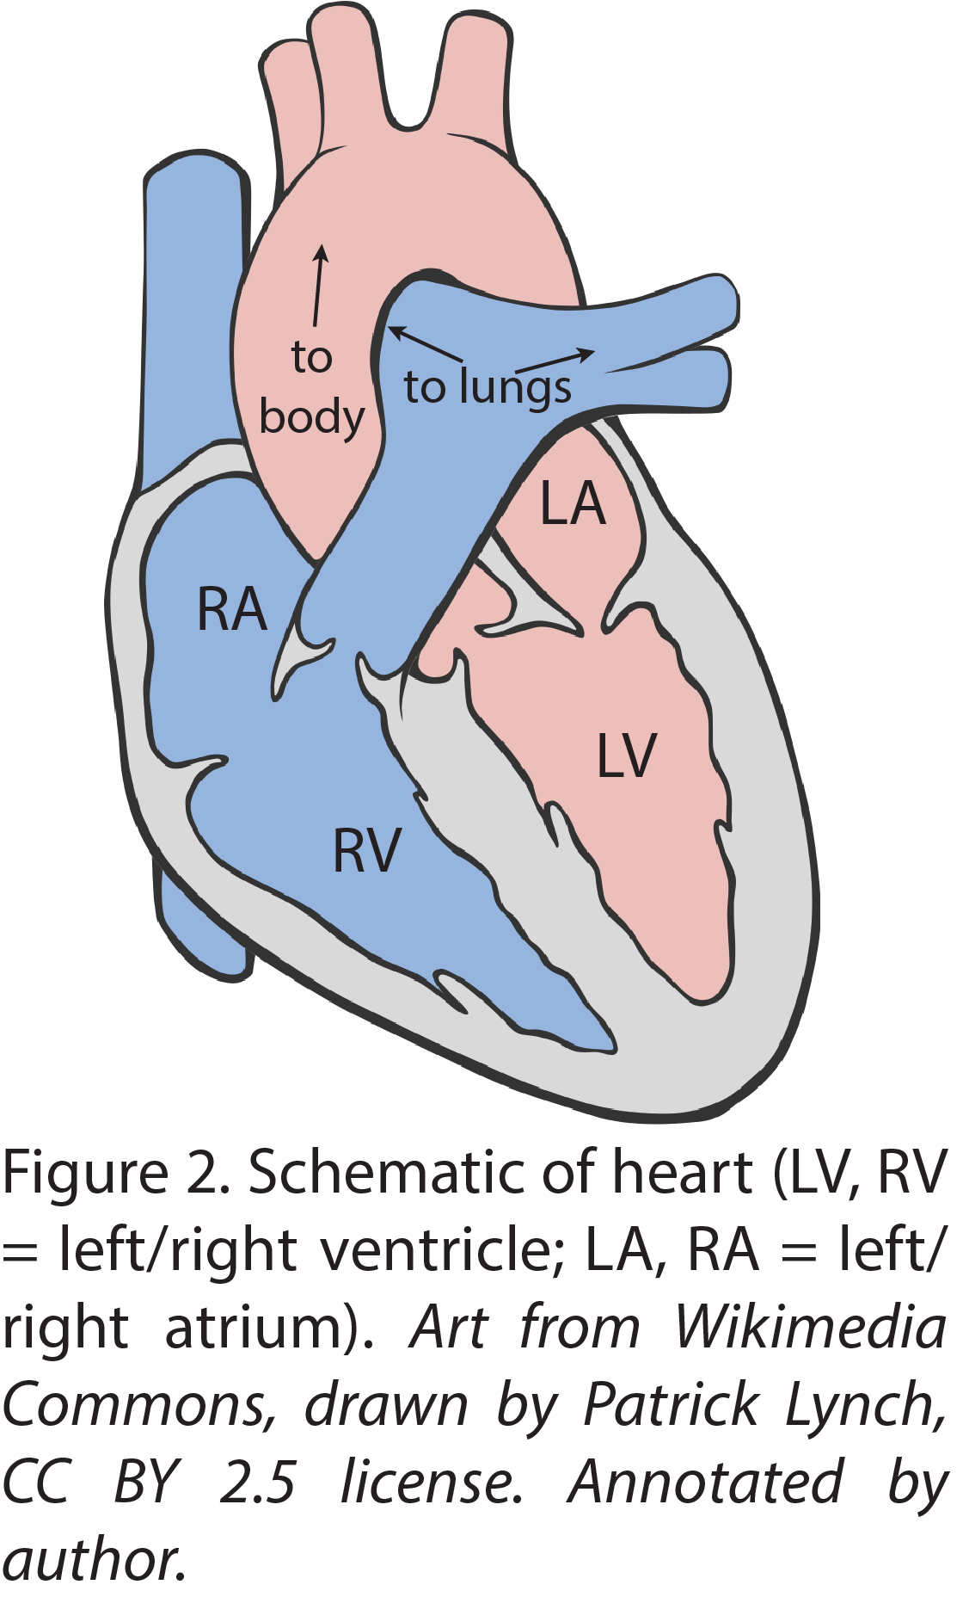

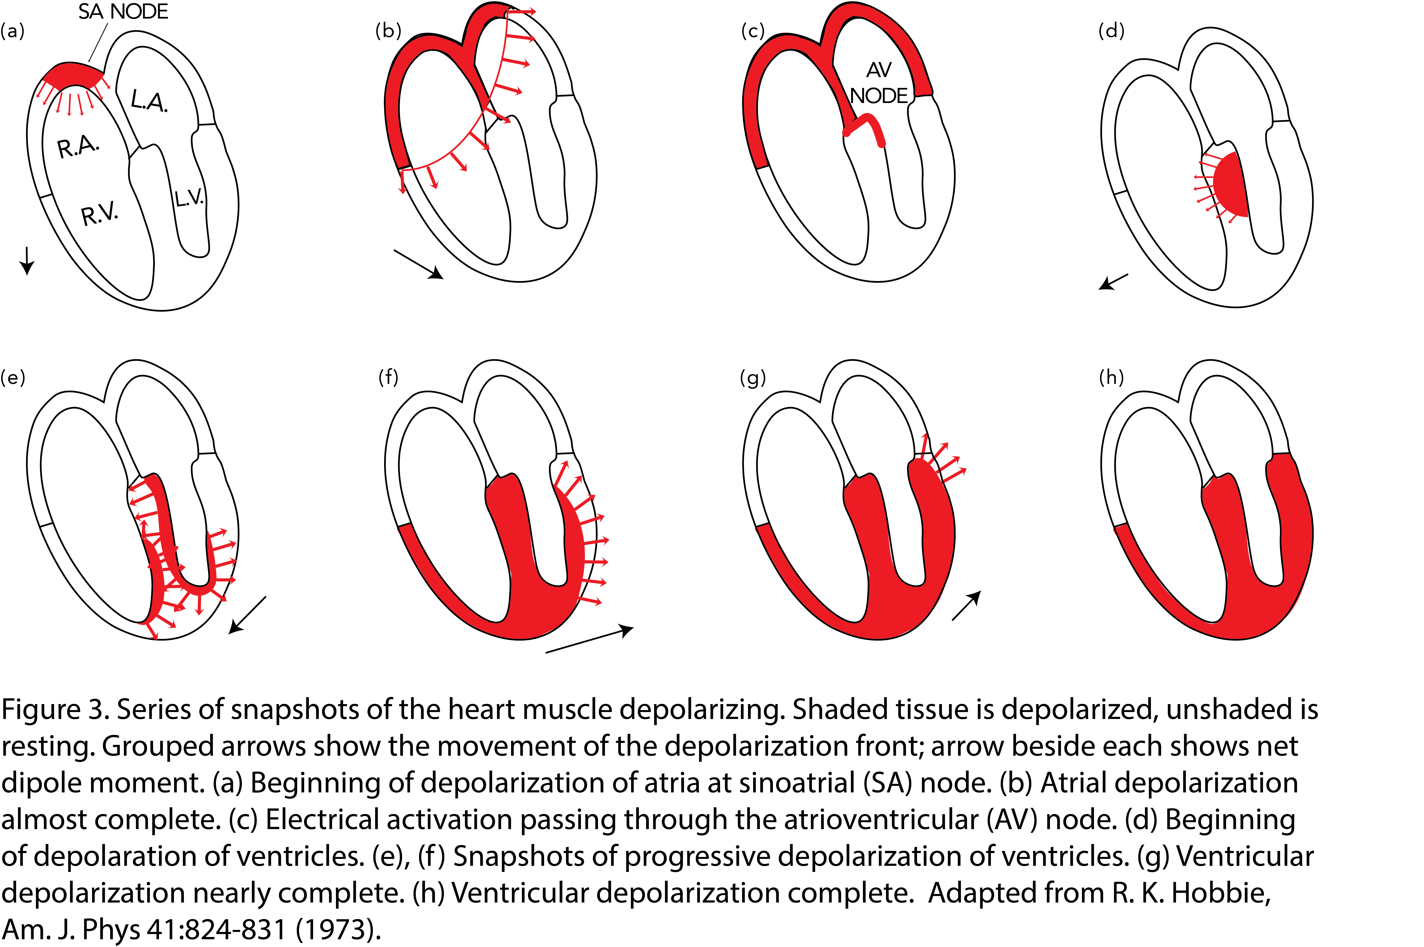

**Appendix: Calculating potential differences in an electric dipole’s field**

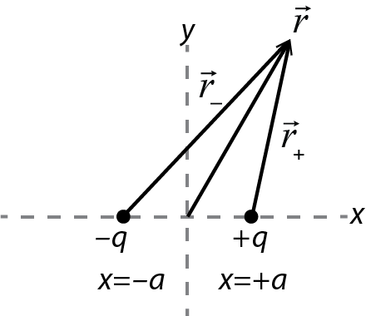The goal of this analysis is to relate measured potential differences on the surface of the body to the components of the heart’s electric dipole moment.

Consider an electric dipole consisting of charges ±*q* at *x* = *a* and *x* = -*a*. The potential of the dipole at any location  can be found by adding the potentials of the individual charges:

 (A.1)

If we embed this dipole in a dielectric with dielectric constant , the potential, like the electric field, is reduced by a factor of :

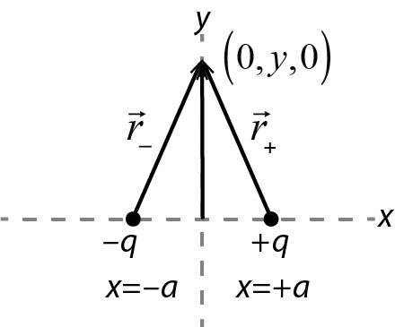  (A.2)

In the dipole investigation at the beginning of lab, you found from an electric field diagram that for a horizontal dipole, is constant along the *y*-axis. You can now confirm this mathematically. Apply (A.2) to any location  on the *y*-axis; , as shown in the figure, and consequently  at any *y*. As a result, produced by this dipole between any locations *y*1 and *y*2 on the *y*-axis is zero:[3]

 (A.3)

Now consider finding the potential difference between two points on the *x*-axis that are equal distances *r* from the origin (at *x* = *r* and *x* = -*r*). The potential at *x* = *r* is given by

 (A.4)

Using the definition of the magnitude of the dipole moment , in the case *r* >>*a*, the denominator of the fraction can be approximated as *r*2 and this can be written as



 (A.5)

The same procedure gives the potential at *x* = -*r* as

 (A.6)

The potential difference between *x* = +*r* and *x* = -*r* is therefore

 (A.7)

The dipole moment of a dipole constructed this way points in the positive *x*-direction. The heart’s dipole moment changes direction during the cardiac cycle, so this is not a complete model of the heart’s dipole moment. However, the heart’s dipole moment  can always be written as the sum of *x*- and *y*-components  and. For a dipole with its dipole moment in the *y*-direction, everything we worked out above applies with *x* and *y* switched, so now the *x*-axis is an equipotential and (A.7) gives the potential difference between locations *y* = ±*r* on the *y*-axis.



Here is the really useful (and cool) point: For any electric dipole, because the axis perpendicular to the dipole is an equipotential, the potential difference between two points on the *x*-axis depends only on the *x*-component of the dipole , and the potential difference between two points on the *y*-axis depends only on . So, in an electrocardiogram, we can measure V between two points on a horizontal line (Lead I) to determine , and we can measure V between two points on a vertical line to determine . In other words, if is measured between ±*x* and if is measured between ±*y*:



and (A.8)



which can be solved to give

and . (A.9)



It turns out that the complexities of human physiology make it difficult to directly measure a potential difference along a vertical line. Due to the way the electric field spreads through the body, it turns out that effectively Lead II is located at 60° to Lead I. Consequently, we use trigonometry to calculate  from the Lead I and Lead II measurements as follows.



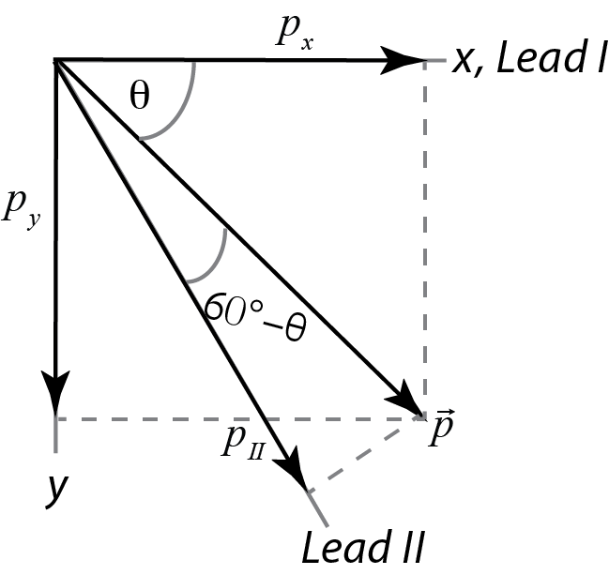

Consider a dipole oriented at an arbitrary angle  as shown. The horizontal and vertical components  and are given by



and . (A.10)



The component of the dipole along Lead II, which we can notate , is given by



(A.11)



which can be simplified using an angle difference formula to

(A.12)



We can then solve for in terms of and:



(A.13)



Finally, we note that the relationship we found above between and and the voltages measured along the corresponding axes is true for any combination of a dipole component and the voltage measured along the corresponding axis. So, it is also true that the component of the heart’s dipole along Lead II is related to the Lead II voltage by



 (A.14)

If the distances at which the leads are all measured are roughly equal, , we can approximate the components of the dipole moment from:

Horizontal:



Vertical:



This pair of equations is true at every instant in time. Within the limits of the approximation that the distances are all the same, the proportion between any component of the dipole moment and the corresponding voltage is the same. Therefore, to plot the time-dependent dipole moment, you can do the calculations and plotting just using the voltages.

To find the maximum dipole moment, find the peak signal in whichever lead shows the strongest signal, and then find the value of the other lead at that same instant of time. Then, use the correspondingand to find the maximum dipole moment.



There are a lot of approximations involved here! Probably the most significant is that the effective angle between Leads I and II will vary somewhat patient by patient due to the patient’s anatomy; the clinical electrocardiogram uses twelve leads to obtain a more comprehensive picture of the three-dimensional behavior. We are doing this simplified analysis so that you understand the basic physics and get a feel for the complex fields generated by the beating heart. If you go on to become a cardiologist, you’ll find that there are more sophisticated and hence more accurate ways to analyze the data.

1. Because the electric fields of the heart are altered by spreading through the body, it turns out that instead we must do a calculation using other measurements, which will be explained in the next part of the lab.
2. Mathematically calculating the dipole moment from the potential difference is simplest if the two points are equal distances from the dipole on opposite sides, which is why you considered that arrangement in the questions above, but you don’t actually have to do it that way
3. Clarification of a possibly confusing point: Not only is  *constant*, its *value* happens to be zero; what matters is that has the same value for any *y*, so that the potential *difference* between any two points on the *y*-axis is zero.