Introduction to Electrocardiography
Catherine H. Crouch (Swarthmore College) and John W. Hirshfeld Jr., MD (Perelman School of Medicine, University of Pennsylvania)

The electrocardiogram (ECG) is a ubiquitous and uniquely valuable medical diagnostic. It is quick, requiring just a few minutes to set up and less than a minute to acquire; inexpensive; completely safe, noninvasive, and painless; and reveals a wealth of information about the heart. The electrocardiogram is a fundamentally electrical measurement, as suggested by its name. As the heart beats, it produces a repeated time-varying electric dipole moment. The ECG records a set of time-varying potential differences on the surface of the body that are produced by this changing dipole. Understanding the electrical basis of the measurement may help avoid errors in interpretation frequently made by trainees and non-specialists.,

Electrocardiography is a complex subject, and there is a lot to know about it; we can only begin to explore it in the time we have! The broad questions we will address include:
- Why does the heart produce a moving electric dipole moment, and how is that moving dipole moment measured by an electrocardiogram?
- How do measurements of the moving dipole moment reveal heart disease?
- Why is the heart’s electric field so much greater than those produced by other muscles or the brain, all of which are made up of electrically active cells?

This introduction aims to build up your understanding with the following sequence of ideas:
- Muscle cell contraction is activated by cell membrane depolarization. A muscle cell contracts when its membrane is depolarized; contraction is sustained until repolarization, when the cell relaxes.
- The flow of current associated with depolarization produces a moving electric dipole moment, which in turn produces a changing electric field on the body’s surface.
- Because the dipole moment comes from the current that flows during depolarization or repolarization, there is zero dipole moment and thus zero electric field whenever no depolarization or repolarization is taking place, including during the time between depolarization and repolarization.
- In the heart, for each heartbeat, depolarization initiates in a small region, normally the sinoatrial node, and spreads throughout the entire heart in a highly coordinated fashion. Repolarization occurs after a significant delay.
- As depolarization spreads across the heart, the heart’s total electric dipole moment at any instant in time is the vector sum of all of the dipole moments of the parts. Because the cells are not all activated simultaneously, but are activated in an exquisitely timed sequence in order for the heart to function, this total dipole moment changes both magnitude and direction throughout a single heartbeat.
- This coordinated wave of depolarization, combined with the repolarization delay, causes the heart to be the dominant source of the electric field on the body surface.
- The electrocardiogram measures multiple distinct potential differences on the surface of the body, as a function of time. Each is proportional to the component of the heart’s electric dipole moment vector along the axis on which it is measured. The entire moving dipole moment can be reconstructed from the set of potential differences.
- Disrupting the sequence of electrical activation, or changing the heart’s structure, changes the magnitude, direction, and/or time dependence of the heart’s dipole moment vector significantly, giving the ECG its diagnostic power.

In this reading, many biomedical terms are introduced in italics. It is not necessary for the purpose of our physics course that you understand these terms. However, as some of you have also studied bioelectrical phenomena and/or electrophysiology in other contexts, we provide the terms to help you make those connections. If they aren’t familiar, don’t worry!

- Electrical activity of muscle cells and muscle tissue (a continuous group of muscle cells).
We have previously discussed how every living cell, in its “resting” state, has a charged cell membrane, with a layer of positively charged ions on the outside of the membrane and a negatively charged layer on the inside. When the membrane is charged to its resting state, it is said to be polarized. In the resting or polarized state, the interior of the cell is at a potential of -90 mV with respect to the exterior. The electric field of this arrangement of charge is strong within the membrane, but nearly zero inside and outside the cell. Consequently, cells in their resting state produce almost no electric field outside the body.

Specialized proteins called ion channels cross the cell membrane and control the flow of ions into or out of the cell. Many of the most important activities of cells involve changes in the charge state of the membrane that result from ion channels opening to allow the free flow of ions, and then closing again.

In nerve and muscle cells (“excitable cells”), an electrical stimulus can cause depolarization of the membrane — ion channels open to allow positive ions to flow in and negative out, so that the previous polarization is mostly eliminated. In muscle cells, depolarization activates contraction; in nerve cells, the depolarization itself is the signal carried by the nerve.
Depolarization does not occur everywhere at once along a nerve cell (axon) or in a muscle tissue. Rather, ion channels open at the location of the stimulus, allowing positive ions to travel inward, depolarizing the membrane in that location. This membrane depolarization is called an action potential. Neighboring ion channels are subsequently triggered to open by the nearby change in membrane potential, and the boundary between the polarized and depolarized region moves. The action potential propagates through the tissue or along the axon.

A simple model of how this proceeds in an elongated cell such as an axon is shown in Figures 1a and b. At the moving boundary, current is flowing across the membrane into the cell, and also flowing in the direction of the moving boundary. In muscle tissues such as the heart, the geometry is different but the principle is the same: there is a current flow right at the moving boundary of depolarization.

- Depolarization produces a moving dipole moment in a cardiac muscle cell
Recall that the resting (polarized) state of the cell produces negligible electric field outside the cell, although a strong field exists within the cell membrane. The part of the cell that is still depolarized likewise produces very little electric field outside the cell, because the field of the positively charged outer layer is canceled by that of the inner negative layer. By the same reasoning, the part that is finished depolarizing also produces very little field.

Consequently, the electric field outside the cell is produced primarily by the moving boundary, which can be shown to be equivalent to the field of a moving electric dipole oriented as shown in Figure 1c. This can be qualitatively understood in part as follows: As the positive ions move into the cell, this is equivalent to positive charge moving along the length of the cell in the direction of the depolarization boundary. The whole system remains electrically neutral, so effectively that positive charge is followed closely by a neutralizing negative charge.

Figure 1c does not show repolarization (return to the resting charge state of the membrane) at the far left of the cell. Repolarization similarly involves movement of an oppositely directed dipole, so in these other types of cells, the depolarization and repolarization dipole fields nearly cancel out, greatly reducing the strength of the resulting field. But not in cardiac cells! This is part of why the heart’s electric field is stronger than the field of other muscles.

- The heart’s electrical signal comes from actively depolarizing (contracting) cells; no signal means no depolarization or repolarization.
As stated previously, resting cells produce essentially no net electric field outside. Actively depolarizing cells, however, produce a dipolar electric field. Consequently, potential differences on the surface of the body arise entirely from depolarizing (contracting) cells, or repolarizing (relaxing) cells.

Looking ahead to the measured electrocardiogram for a moment, this means that whenever there are no actively depolarizing cells in the heart, the electrocardiographic voltage will be essentially zero — essentially no potential difference is measured. (Other nerve and muscle cells may be depolarizing, but the potential differences they produce are a thousand times smaller than those produced by the heart in the active stages of the electrocardiogram.)

Uniquely among excitable cells, cardiac muscle cells do not repolarize within a few milliseconds; rather, they remain depolarized for hundreds of milliseconds. During this extended period of depolarization (or refractory period), the cell remains contracted and is unresponsive to any further electrical stimulation. This produces a corresponding period in the electrocardiogram with no electrical signal.

- The total dipole moment of the heart is the vector sum of all dipoles in the moving depolarization front, which changes in a regular pattern throughout a single heartbeat.

For any tissue made up of multiple cells, its total dipole moment is the vector sum of all the dipole moments in it. In the heart, the individual fibers do not all contract simultaneously; the heart would not function properly if they did. Instead, the different parts of the heart muscle contract according to a carefully controlled sequence and timing. As a result, the total dipole moment of the entire heart changes direction and magnitude throughout a single heartbeat, and repeats consistently from cycle to cycle. (If that sounds rather magical … well, there is no denying how extraordinary the heart is!) The direction, magnitude, and timing of the dipole moment reflect the pattern of contraction of the heart muscle.
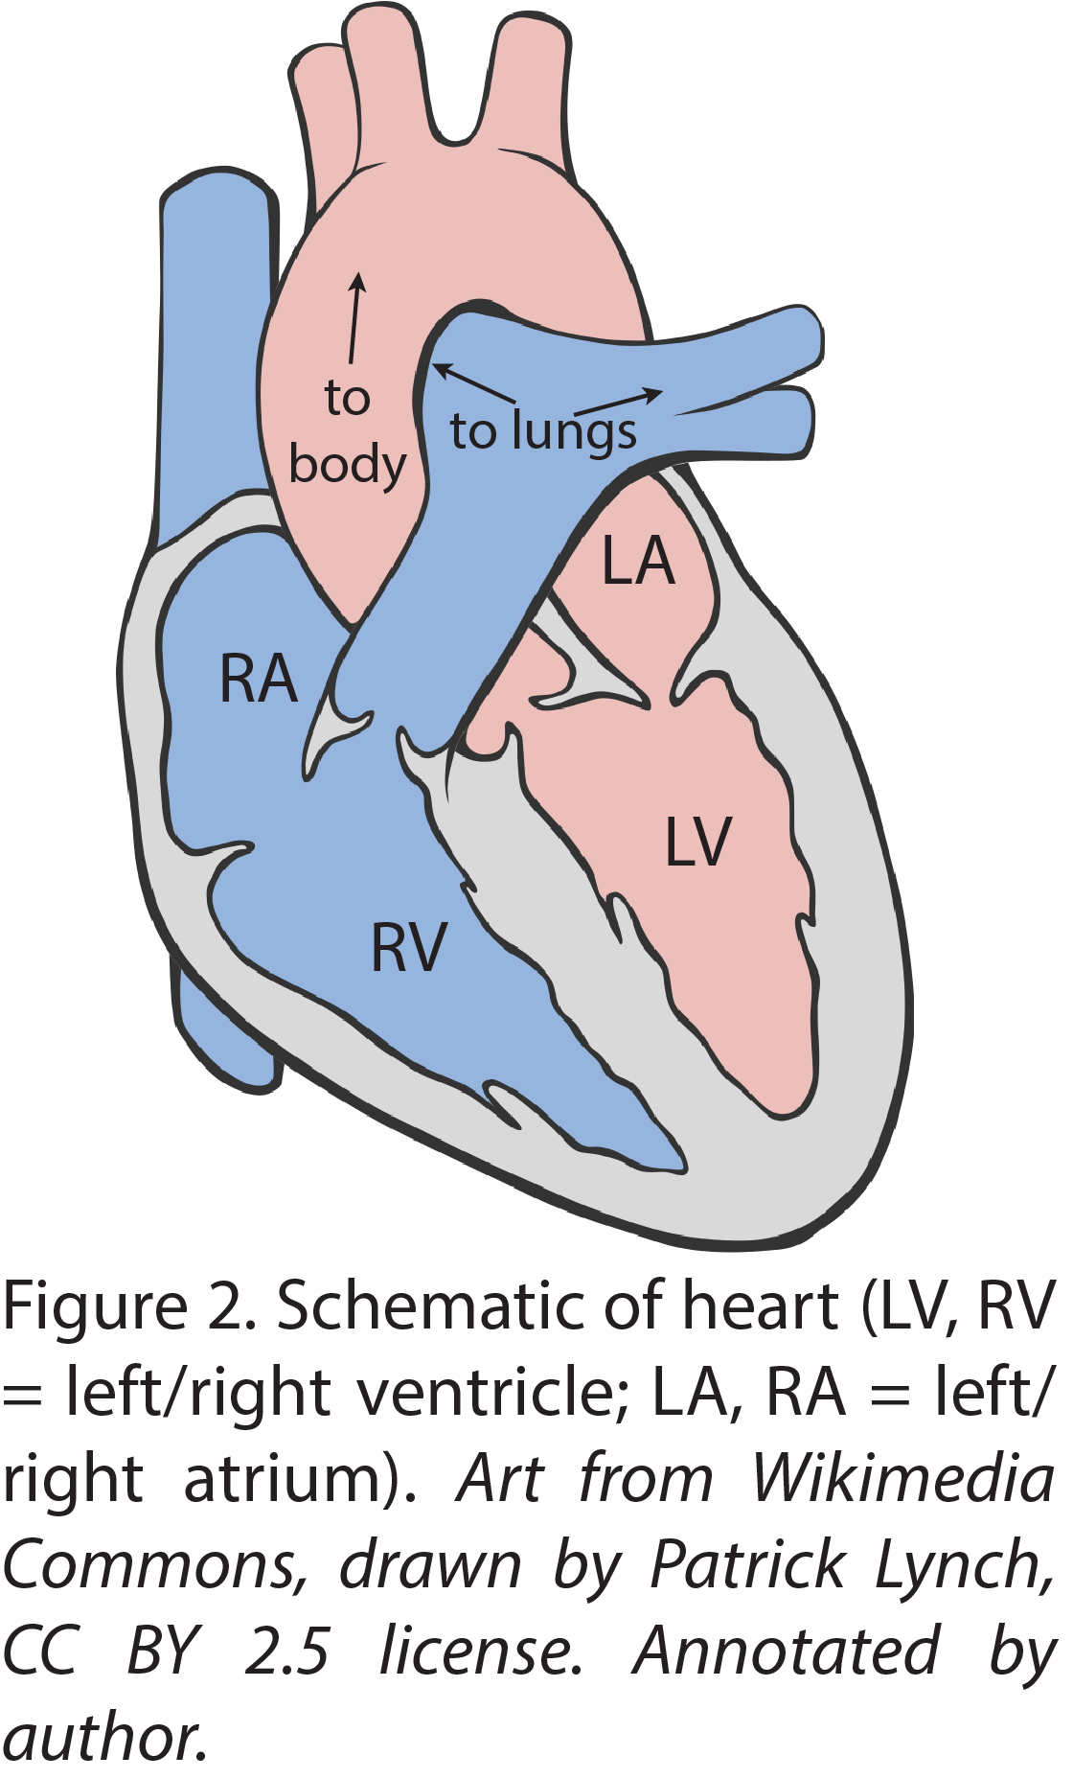
To illustrate this more concretely, let’s look at the parts of the cardiac cycle. Figure 2 shows a schematic cutaway view of the four-chambered human heart. The two small upper chambers are the right and left atria; the two large lower chambers are the right and left ventricles. The ventricles are larger than the atria in order to generate more force. Similarly, the thicker left ventricle has more muscle than the right in order to generate more force, because the left ventricle pumps blood to the body, requiring a higher pressure than is required by the right ventricle to pump blood to the lungs.

During the cardiac cycle, first the relaxed atria fill with blood, then contract, expelling that blood into the ventricles. Next the ventricles contract (and simultaneously the atria relax), pumping blood from the ventricles out into the lungs and the body. Finally, the ventricles relax in order for the cycle to repeat.

Figure 3 shows a schematic of how depolarization travels across the heart muscle in order to accomplish this sequence of contractions and relaxations. Figure 3a shows where the electrical stimulus of the entire cycle begins, at the sinoatrial (SA) node. Initially just a tiny patch of cells depolarizes; then the depolarization spreads across the atria, as shown in Fig. 3b. When depolarization of both atria is complete, there is a pause, during which the electrical stimulus passes from the atria to the ventricles through a small region called the atrioventricular (AV) node (Fig. 3c). Then depolarization of the ventricles begins, and travels across the ventricular tissue, as illustrated by the series of snapshots shown in Figs. 3d-g. The ventricles are not depolarized all at once; rather, depolarization spreads across the ventricles during a period of approximately 80 milliseconds. Finally, after the ventricles have completely depolarized and the refractory period has passed, the ventricles re-polarize (not shown).

At each moment, the total dipole moment of the heart is the vector sum of all of the moving dipoles of the individual cells that are depolarizing. In each part of Fig. 3, a selection of vectors for different parts of the moving depolarization front are shown, along with their vector sum next to the label letter.

You do not need to remember or understand the details of exactly how the depolarization travels across the heart muscle. What is important is to understand the mechanism of how the general pattern gives rise to the electrocardiogram. (Once you have mastered this material, you should be able to make sense of how Figures 3 and 4 relate to one another, but you do not need to memorize Figure 3.)

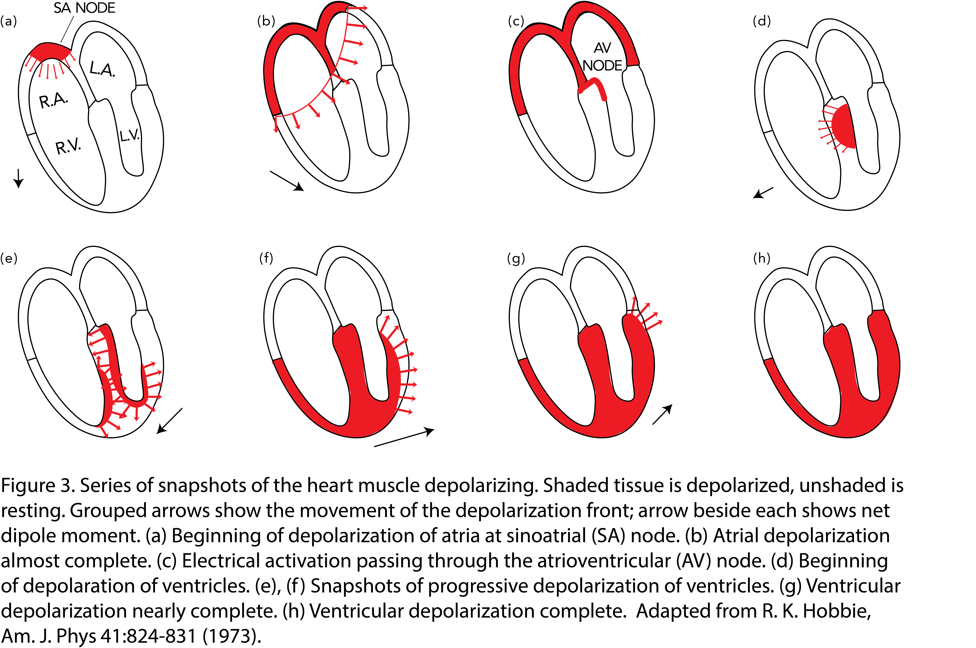

Let’s look at this in one of the measurements that make up the electrocardiogram. Figure 4 shows data from one of the twelve potential difference (voltage) vs. time measurements that make up the clinical electrocardiogram. A pattern corresponding to a single heartbeat repeats five times in the data shown.

The path followed by the depolarization front across the heart produces the sequence of lettered features in the pattern as follows:

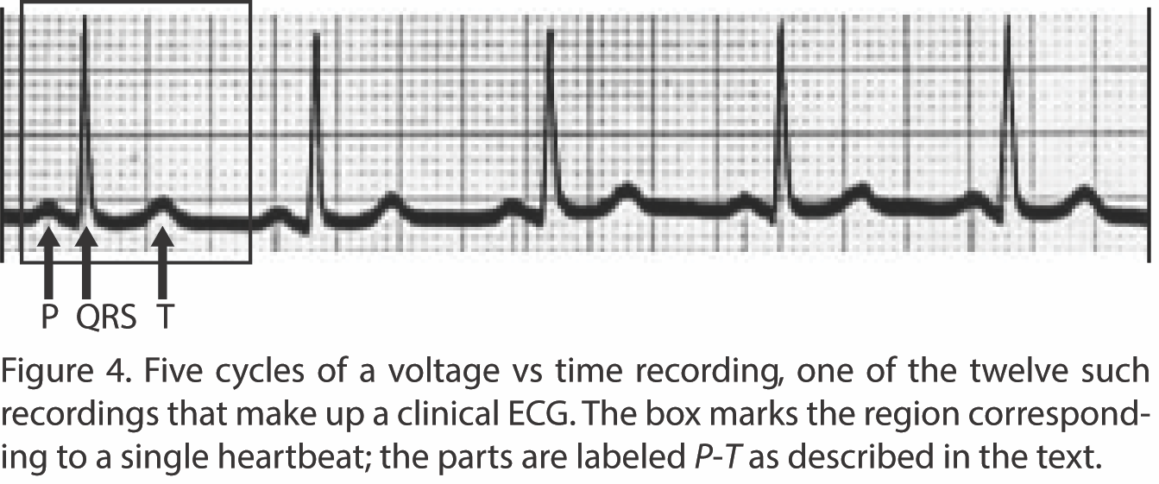
• First, a small feature corresponding to the depolarization of the atria, called the “P wave” for historical reasons, corresponding to Fig. 3b;
• Next, a pause, during which the voltage is zero because no depolarization is occurring, while the signal travels through the AV node from the atria to the ventricles (3c);
• Next, a larger feature corresponding to the depolarization of the ventricles, called the “QRS complex,” which is more elaborate in shape than the P wave due to the more complicated pattern of movement of the depolarization front (3d-g). The simultaneous repolarization of the atria is much smaller, and thus hidden by the QRS;
• Next, another pause (no depolarization), during which the ventricles stay contracted (3h);
• Finally, a feature due to the repolarization of the ventricles, called the “T wave,” which is not as large as the QRS complex because it lasts longer in time (not shown in Fig. 3).

The coordination of the heart’s electrical and mechanical activity is displayed in Figure 5, which shows pressure vs. time in the aorta, left ventricle (LV), and left atrium (LA), and left ventricular volume vs. time, above a simultaneous ECG. Shortly after the QRS complex,

pressure begins to increase in the LV due to ventricular contraction. When the pressure in the LV exceeds the aorta pressure, blood is pumped from the LV into the aorta, corresponding to a decrease in the LV volume. Upon completion of the T wave, the heart muscle relaxes, and the LV pressure falls; when the LV pressure falls below the LA pressure, blood begins to flow from the LA to the LV, filling the LV and thereby increasing the LV volume.

- The coordinated pattern of heart muscle contraction makes the heart the strongest source of electric field in the body

The discussion so far explains how the electrical activity of the heart as a whole produces a moving dipole moment that reveals how depolarization spreads through the heart tissue. The heart has much more localized and concentrated electrical activity than the brain. Neurons in the brain are not coordinated with each other on the same scale as the heart or muscles. As a result, the electrical signal from the heart is a thousand times greater than that from the brain. In fact, when the electrical activity of the brain is measured, the heart’s electrical signal has to be subtracted out to reveal the signal of interest. (However, when other muscles contract, they do produce an electrical signal by the same mechanism, though it is somewhat smaller. For this reason, it is important for the patient to remain still for an accurate ECG.)

- The electrocardiogram measures several potential differences on the surface of the body as a function of time, in order to observe how the full dipole moment vector changes with time

Now that we have established why the heart generates a moving dipole moment, let’s examine how the electrocardiogram (ECG) measures it. The dipole moment is a vector, so we need to determine both its magnitude and its direction as a function of time.

One way to measure a time-dependent vector is to simultaneously measure each of its components. Surprisingly, it turns out that even though potential difference is a scalar, not a vector, the potential difference produced by a dipole between any two points along an axis passing through the dipole is proportional to the component of the dipole moment along that axis. You will investigate this further in lab and on the homework; afterward, you can review the derivation in a separate reading.

Consequently, measuring the potential difference between two points on an axis can be used to determine the component of the dipole moment along that axis. The heart’s dipole moment can in principle be determined by measuring potential differences on three perpendicular axes.
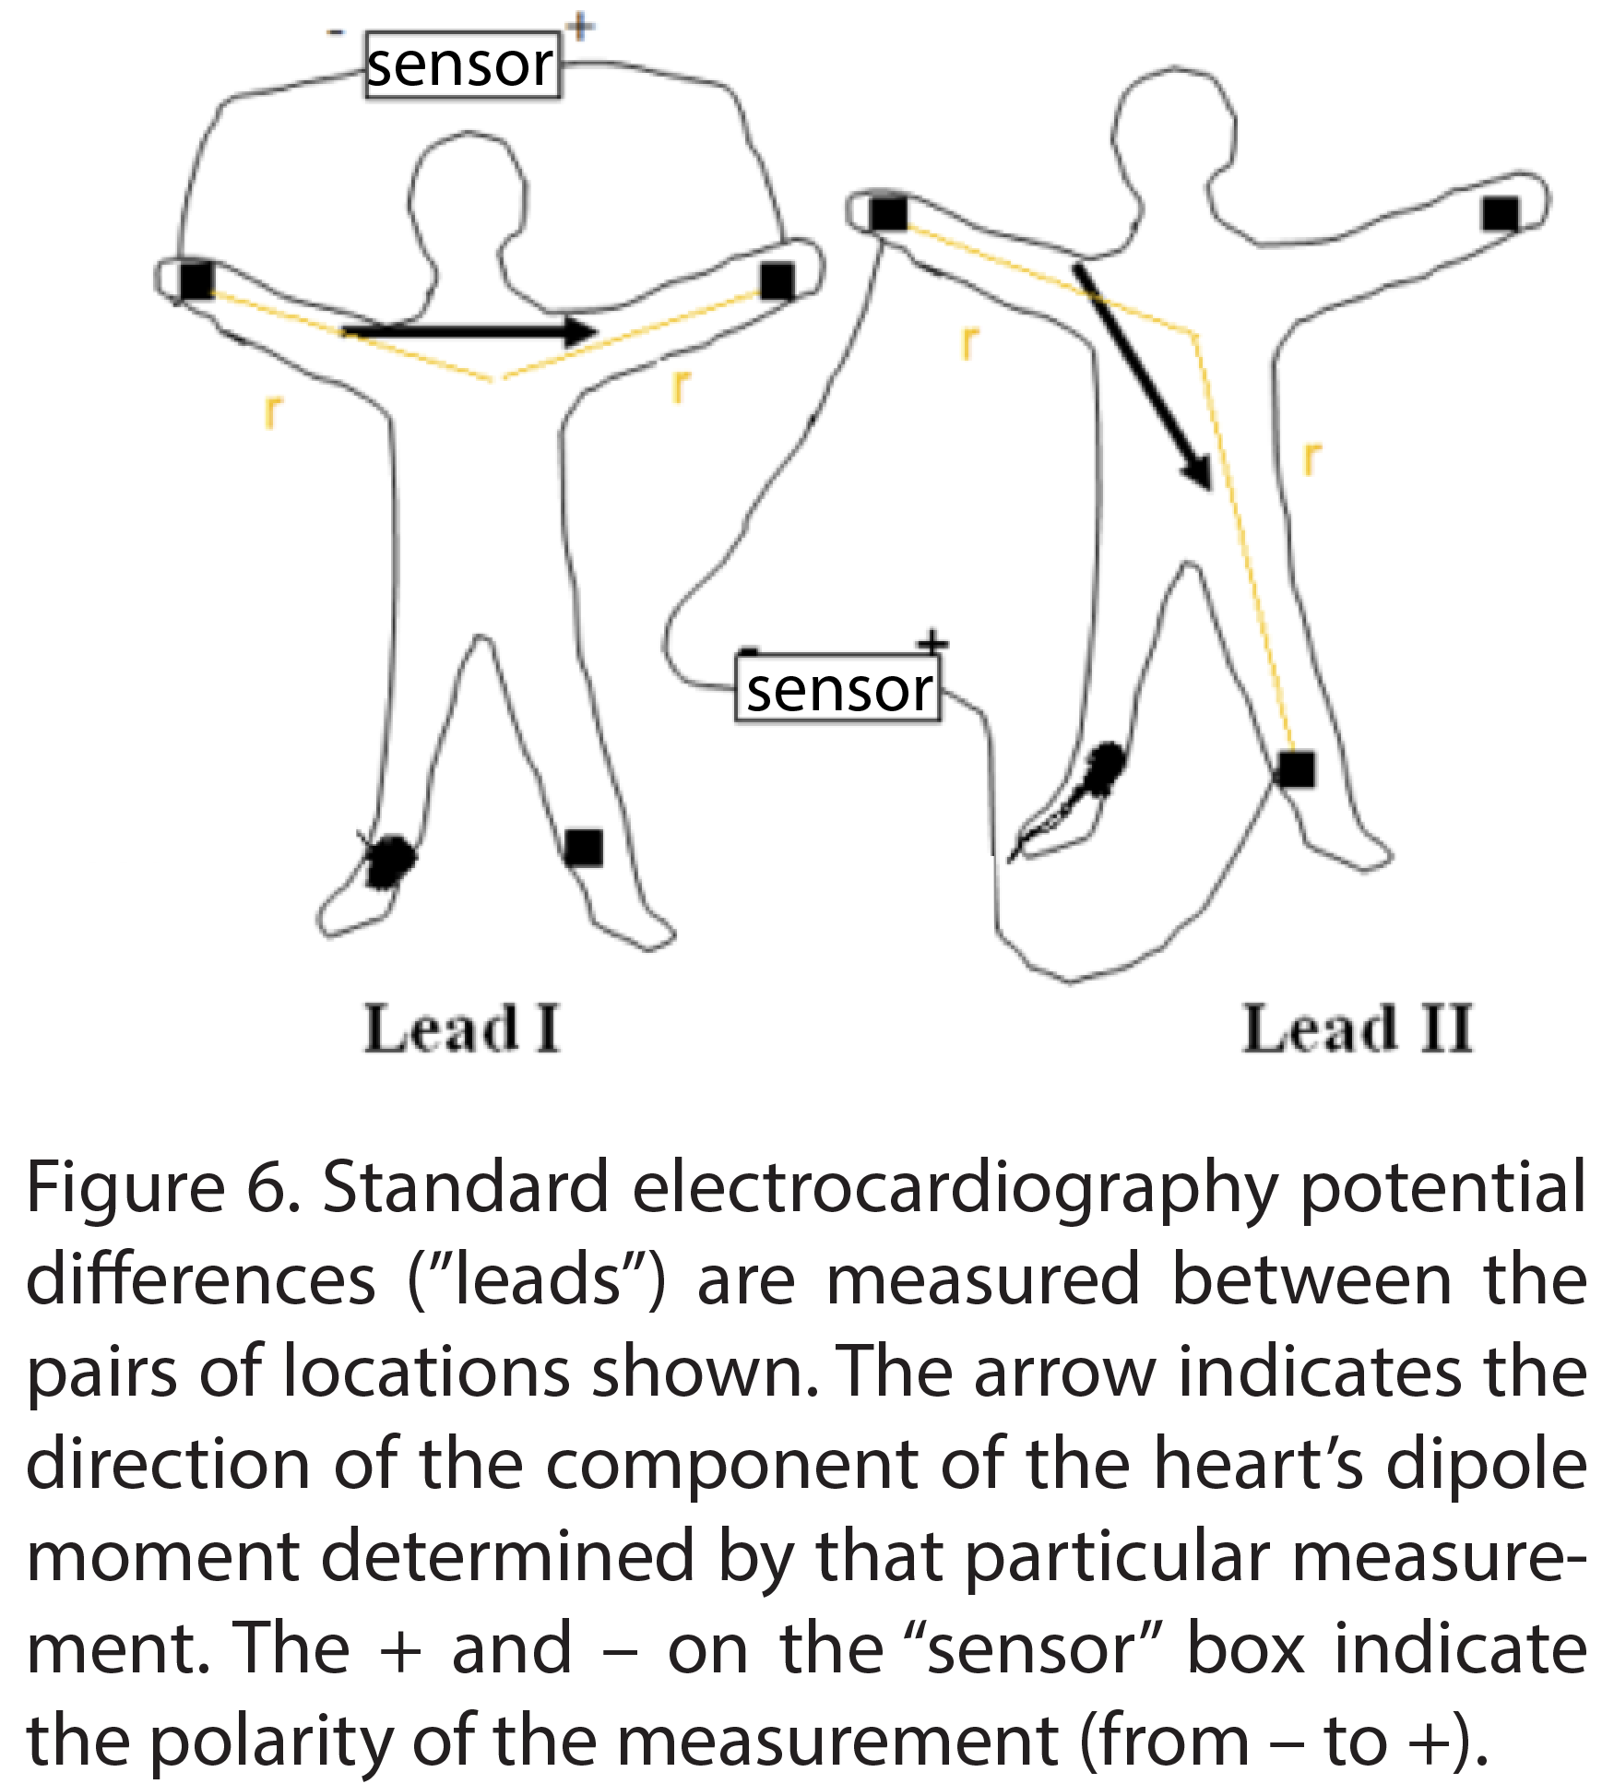
Because the vector direction of the dipole moment holds a great deal of information, it is useful to measure a set of overlapping components that probe useful directions. Each voltage measurement shows directly how the component of the heart’s dipole along the corresponding axis changes with time. The original electrocardiogram invented 100 years ago measured just three different potential differences, all in a plane parallel to the patient’s back (the “frontal plane”), and so revealed only the projection of the heart’s dipole moment into that plane. Due to the positioning of the heart in the body, many of the most significant features of the ECG are present in just frontal plane measurements. A modern clinical ECG measures twelve potential differences, corresponding to 15 degree intervals in each of the frontal and horizontal planes, which together reveal the three-dimensional vector dipole moment.

Figure 6 shows the two potential differences that you will measure in lab, which are two of the three used in the original ECG. They are called “Lead I” and “Lead II” in standard ECG terminology. The name “lead” is given, because a pair of wires to measure the potential difference between two points in an electrical circuit is referred to as a pair of electrical leads.

In lab, you and your lab partner will use your Lead I and Lead II measurements to display the time-dependent projection of the dipole moment into the frontal plane. Think of it as watching the depolarization wave spread across the heart with each beat!

- If disease disrupts the sequence of electrical activation of the heart, this results in altered magnitude, direction, and/or time dependence of the heart’s dipole moment.
Hopefully this reading has helped make it clear how the heart’s electrical activity generates a dipole moment, and how the variation of that vector dipole moment with time reveals the contraction of different parts of the heart muscle. Many different forms of heart disease alter the electrical activation of the muscle, or alter the muscle itself in ways that are evident in the dipole moment. Consequently, these diseases can be diagnosed from the alteration of the ECG (often combined with other clinical data). In class, your instructor will show some examples of clinical data from such diseases and give you the opportunity to relate the change in the ECG to the diseased state.

Selected Bibliography

This is by no means an exhaustive list of possible references.

For those interested in a more advanced and more mathematical discussion of the physics of the electrocardiogram, including justifying modeling a current dipole as a charge dipole, the following two references provide this:

Benedek, George B., and Felix M. H. Villars, Physics With Illustrative Examples from Medicine and Biology: Electricity and Magnetism, 2nd Ed., Section 2.8 (New York: AIP Press and Springer, 2000). This discussion draws heavily on the 1973 article by Prof. Hobbie for its figures, but provides an alternate perspective. Beware: in Figure 2.75, the membrane potential is plotted with the opposite sign from how practicing electrophysiologists use it; don’t use this sign convention unless you wish to confuse your students.

Hobbie, Russell K., and Bradley J. Roth, Intermediate Physics for Medicine and Biology, 4th Ed., Chapter 7 (New York: Springer, 2007). This chapter contains and supersedes the treatment in the American Journal of Physics articles published by Prof. Hobbie in 1973 (Am. J. Phys. 41:824-31 and in 1984 (Am. J. Phys. 52:704-5).

For those interested in more background on voltage-gated ion channels and action potentials:

Alberts et al, Molecular Biology of the Cell. Find “action potential” in the index of whatever edition is easily obtained. In the fourth edition, this section is called “Ion Channels and the Electrical Properties of Membranes and falls partway through Chapter 11, “Membrane Transport.” This text is the authoritative introductory cell biology book, but does require mastery of a lot of vocabulary to read.

Phillips, Kondev, Theriot, and Garcia, Physical Biology of the Cell, 2nd Edition, beginning of Chapter 17 (New York: Garland Science), 2013. Physicists may feel on more familiar ground reading this book, as three of the authors are biological physicists. Keep in mind that this chapter is focused on nerve signal propagation; while the basic molecular biology of the action potential is broadly the same in cardiac muscle cells, there are also critically important differences between axons and cardiac muscle cells.

The archaic acronym “EKG” is also sometimes used, which probably originated from the German spelling “elektrocardiogramm”. Standard medical terminology is ECG.
Salerno SM, Alguire PC, Waxman HS. Training and competency evaluation for interpretation of 12-lead electrocardiograms: Recommendations from the American College of Physicians. Ann Intern Med 2003; 138(9): 747-50. PubMed PMID: WOS:000182661400008.
AlGhatrif M, Lindsay J. A brief review: history to understand fundamentals of electrocardiography. Journal of Community Hospital Internal Medicine Perspectives 2012, 2: 14383 - http://dx.doi.org/10.3402/jchimp.v2i1.14383
In fact, the membrane becomes slightly polarized in the opposite direction, with the inside slightly positive and the outside slightly negative. However, as this polarization is modest compared to the resting polarization, it is conventional to refer to this state of the membrane as “depolarized”.
To be precise, usually “electric dipole” refers to a charge dipole, a pair of positive and negative charges of equal magnitude separated by a small distance, as shown in Figure 1c. The traveling edge is actually a current dipole rather than a charge dipole. However, the human torso is a good conductor, and it turns out that the electric field produced by a current dipole in a conductor is exactly like the electric field produced by the familiar electric charge dipole in a vacuum or dielectric medium, so the charge dipole is a reasonable model. Your instructor can discuss this further with you if you are interested; a more technical discussion can be found in Hobbie and Roth and in Benedek and Villars (see bibliography). Practicing electrophysiologists typically describe the traveling edge as a charge dipole, so we will do the same.
To be precise, moving depolarization and repolarization boundaries close together produce a quadrupolar field.
Einthoven labeled the prominent features of the electrocardiogram with the letters PQRST in sequence. It is thought that he started at “P” because in geometry, points are typically labeled “P”.
This display is known as a Wiggers diagram, named for its originator, cardiologist Carl Wiggers (1883-1963).

